This post was republished to IBM Middleware Technologies at 5:07:08 PM 8/20/2012

Installing Business Process Manager Advanced V8 on Windows 64bit

Category

## Part I – Preparing the setup

I have found that these basic prep steps help prior to installing the product:

1. Create a user that you will use as your BPM administrator account and add it to the Administrators group and to the DB2ADMNS and DB2USERS groups. You will also need this ID later when you create your profiles as this ID is used to write to the databases:

Control Panel > Administrative Tools > Computer Management

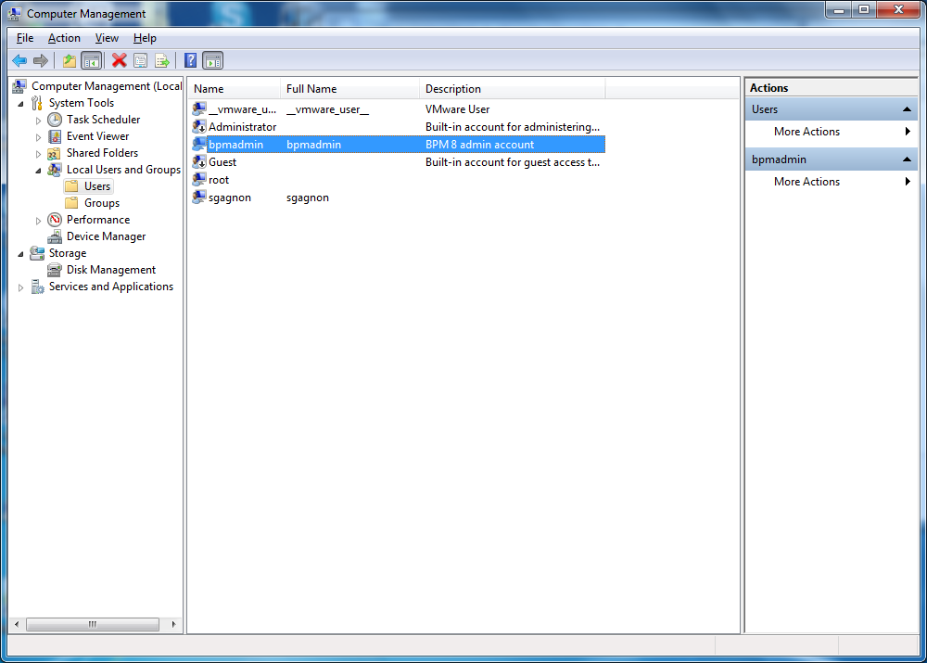

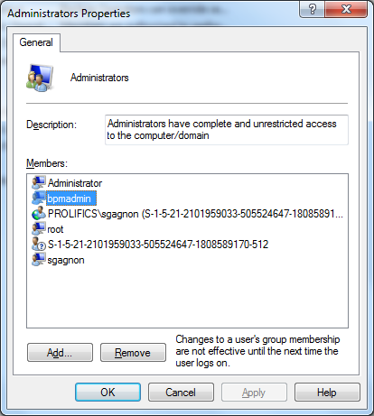

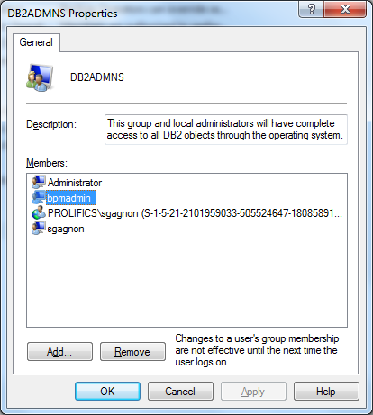

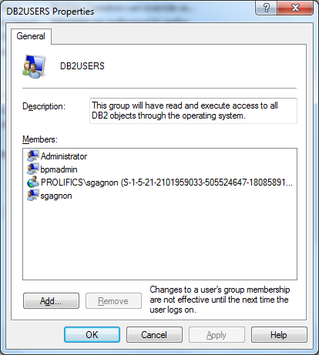

1. Extract all your binaries to the same root directory:

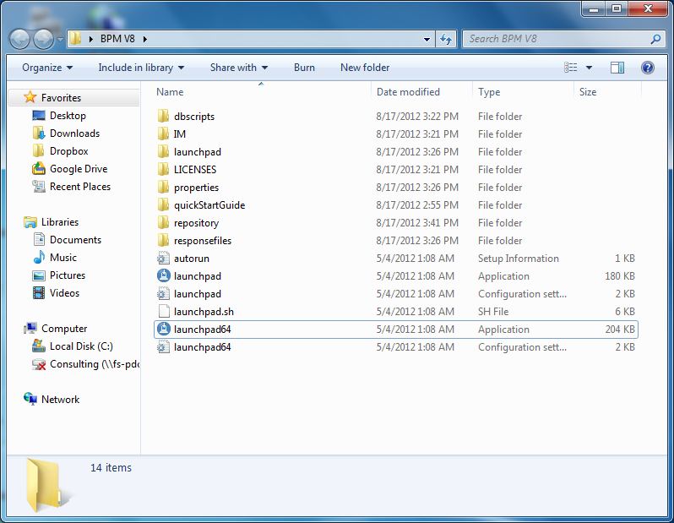

## Part II – Begin the installation

1. As this is a 64 bit installation, open up the launchpad64.exe to begin the installation:

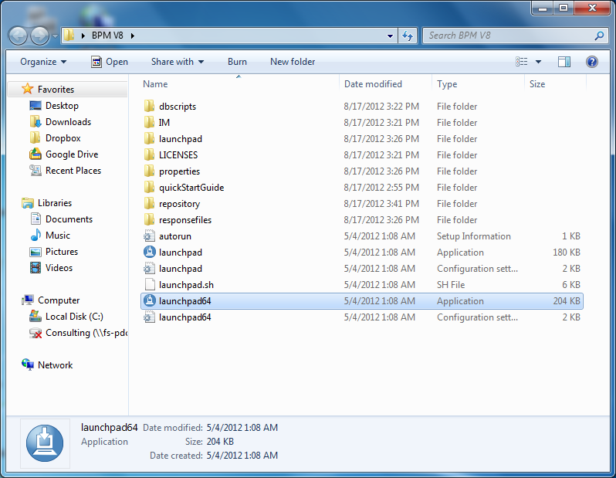

1. Click on using custom installer in the Custom Installation section:

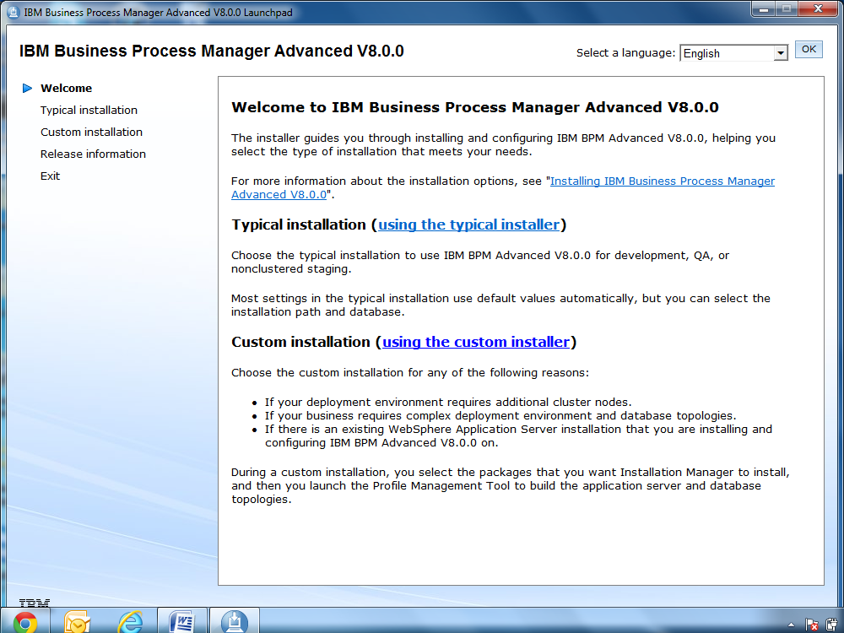

1. Install as an administrative user. Click Install:

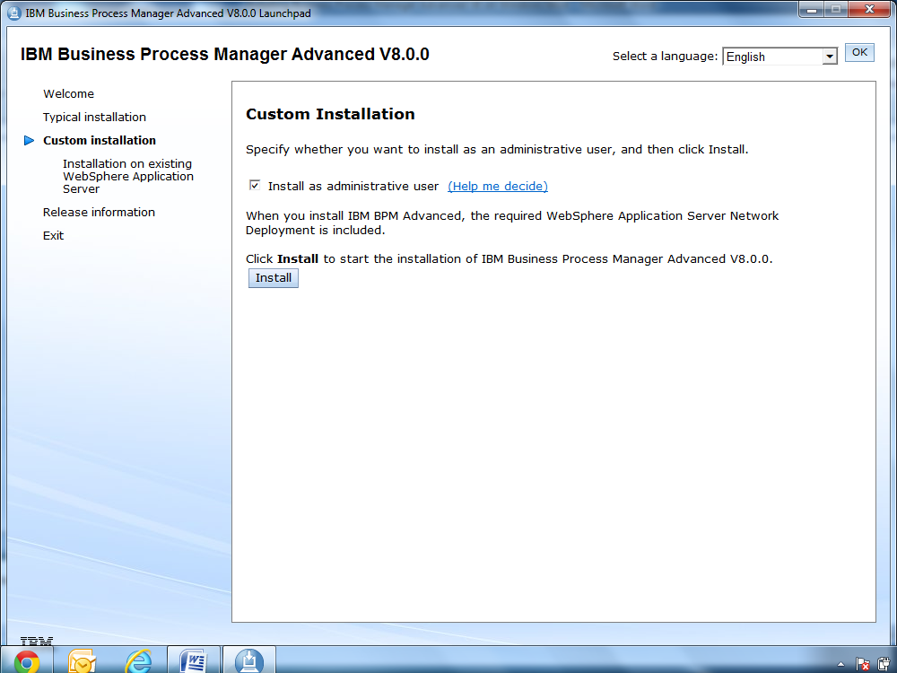

1. This will now launch the Installation Manager as seen below:

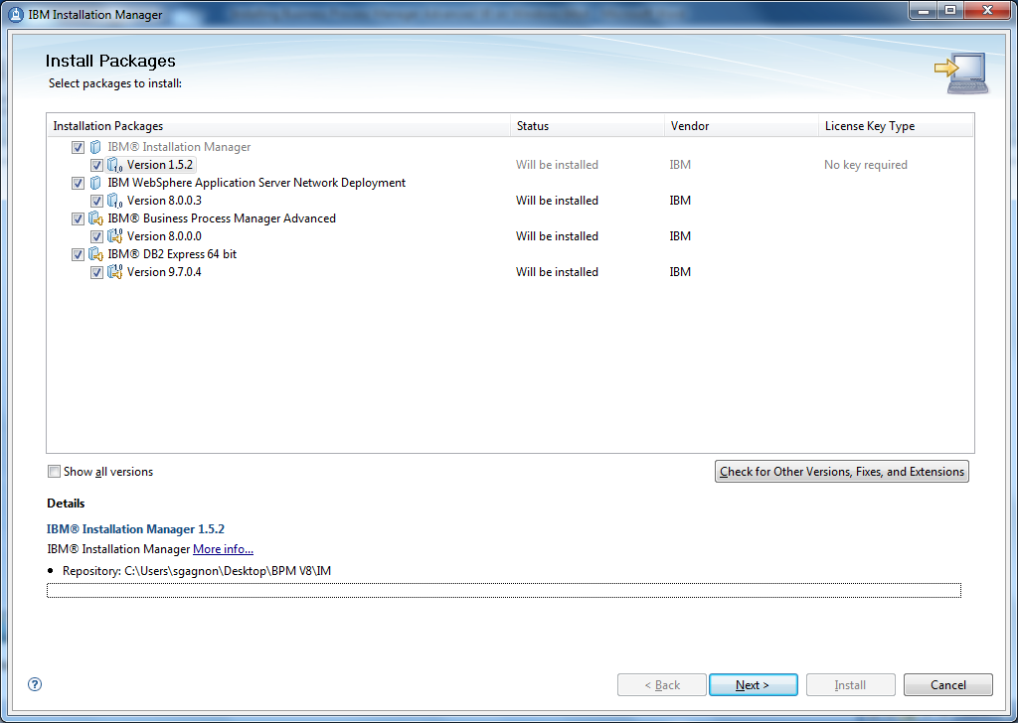

1. Make sure all of the options are selected and click on Check for Other Versions, Fixes, and Extensions to get the latest updates. After you click, you screen will refresh and automatically select the latest versions for all the software packages. Click Next:

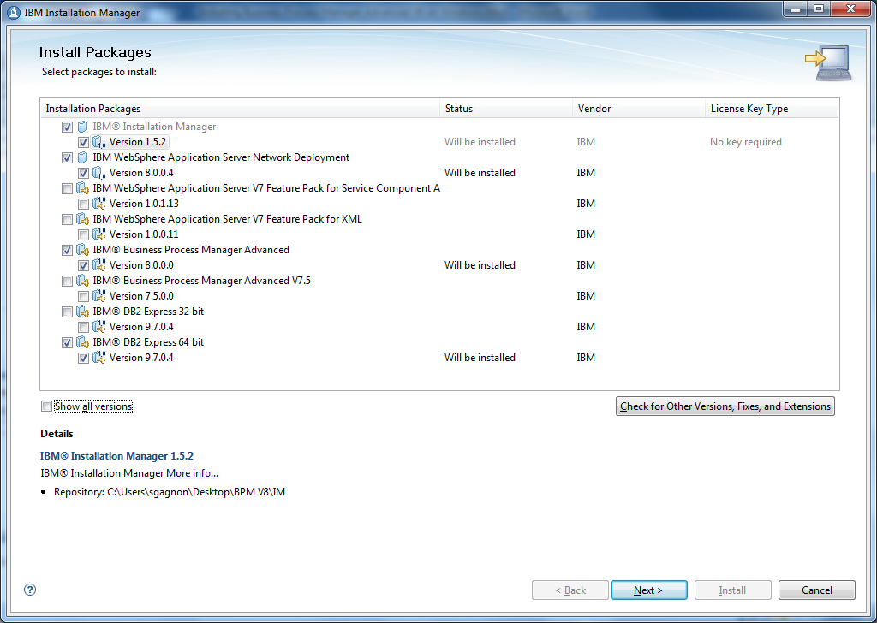

1. Select any additional recommended fixes for you software packages. Click Next:

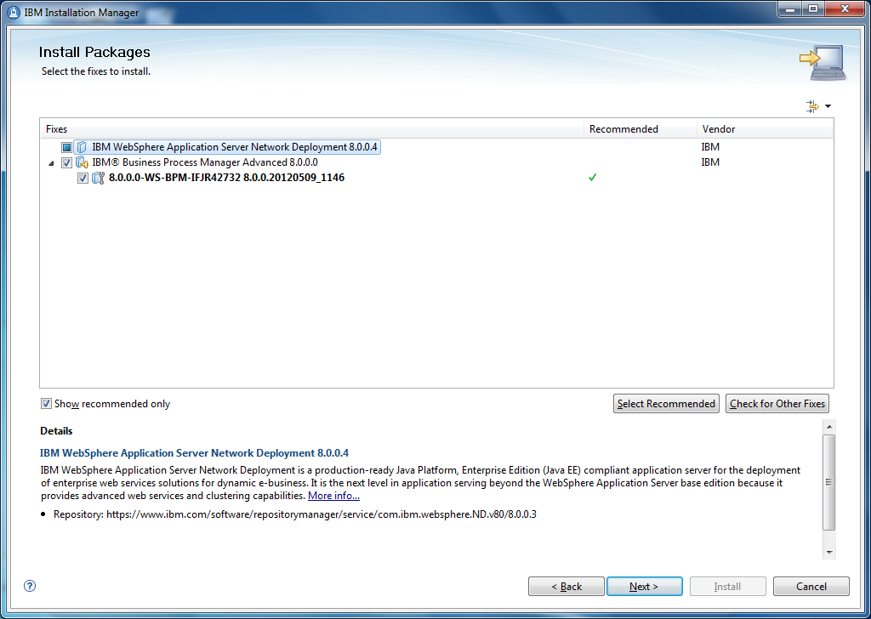

1. Agree to the software licenses and click Next:

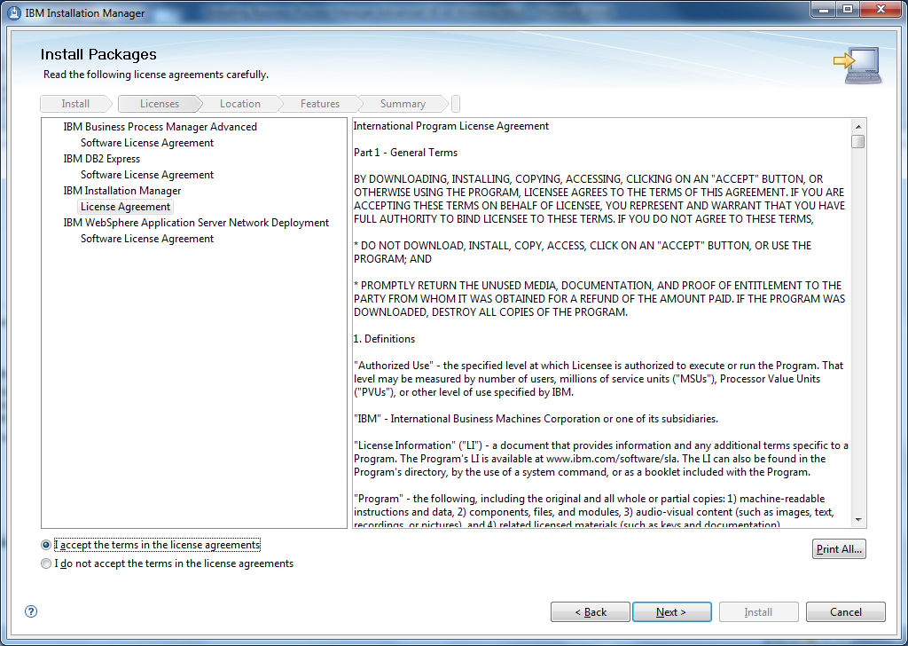

1. Select where you would like to install the binaries too and click Next:

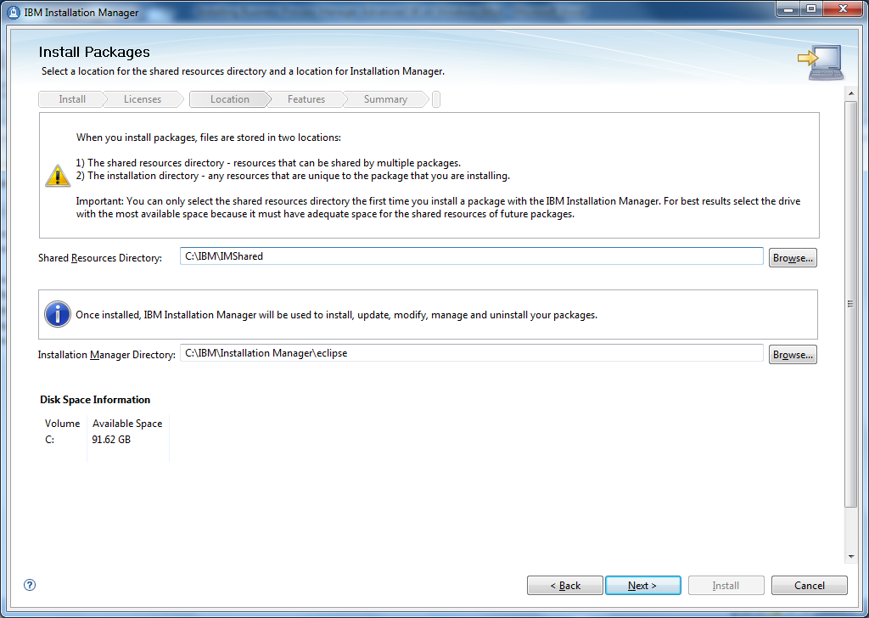

1. I try to keep everything installed in the same directories. So, here I adjust the install path so it matches the directory path in the previous step. Click Next:

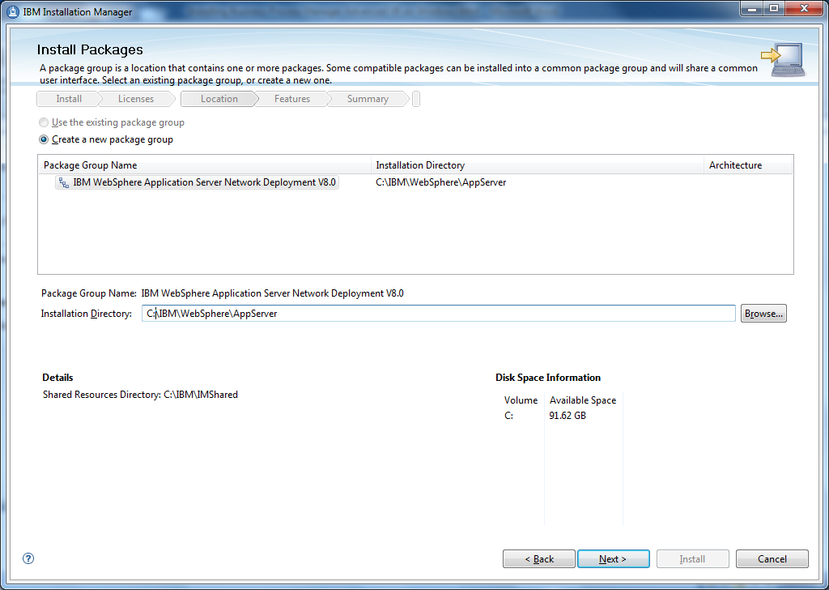

1. Select your language and click Next:

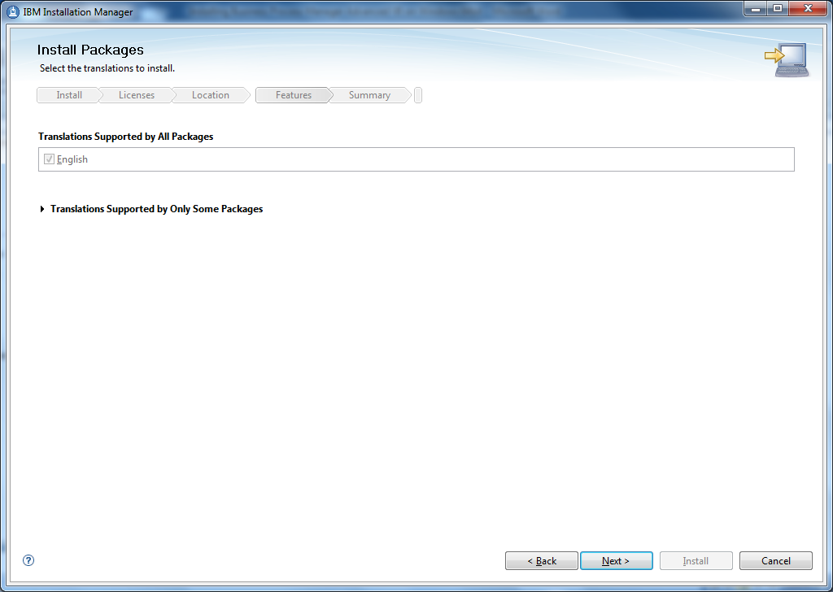

1. Verify the software packages you are installing and click Next:

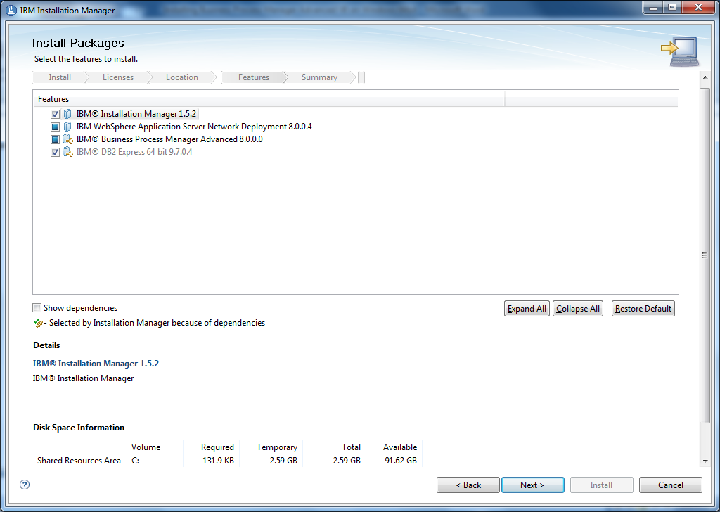

1. On this screen you need to enter the credentials that you created in Part I. Make sure it is the exact same credentials. Click Next:

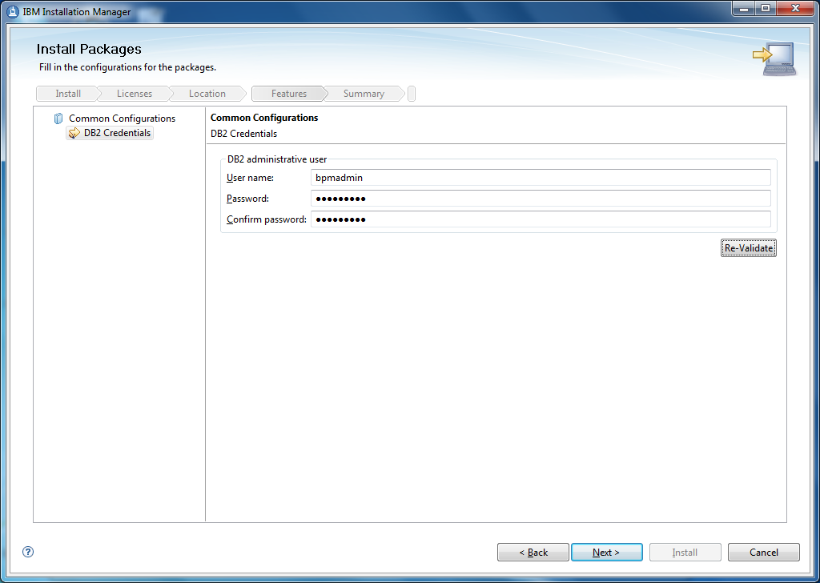

1. Review summary information. Click Install:

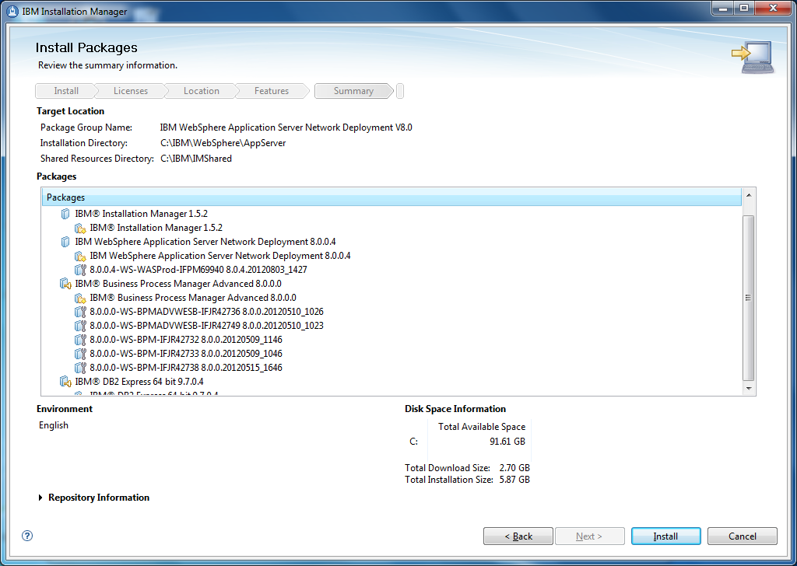

1. The products are installing on your system. Please wait until it completes:

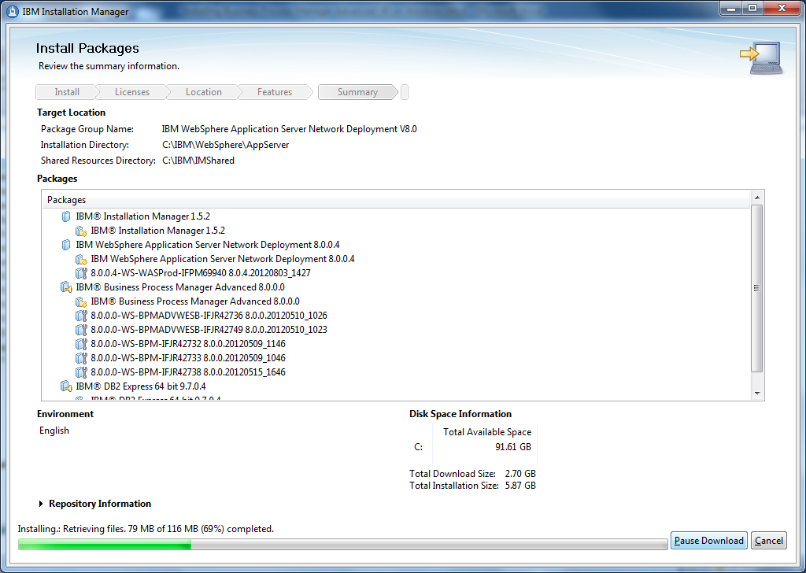

1. Look for a successful installation before proceeding. Select None for which program you want to start. Click Finish:

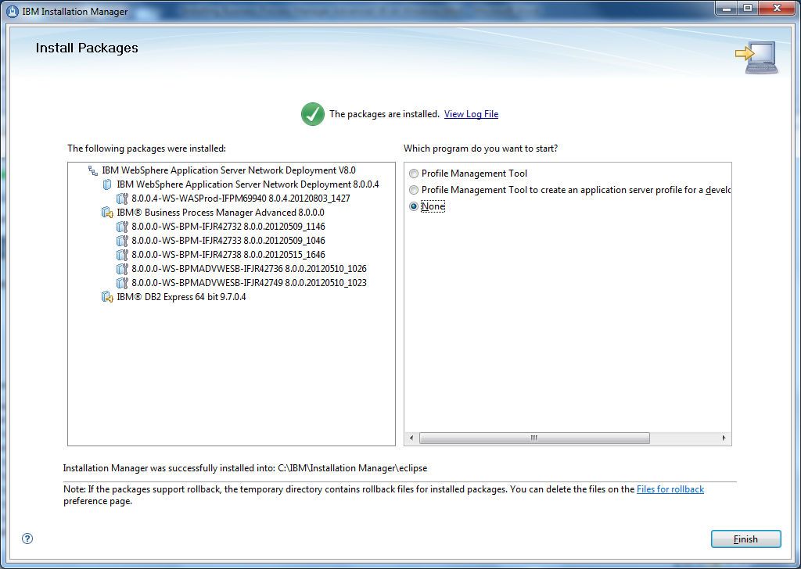

## Part III – Database Script Creation using DbDesignGenerator

1. Open a command prompt and navigate to your installation path of WebSphere (i.e. C:\IBM\WebSphere\AppServer\util\dbUtils). Run the command DbDesignGenerator.bat:

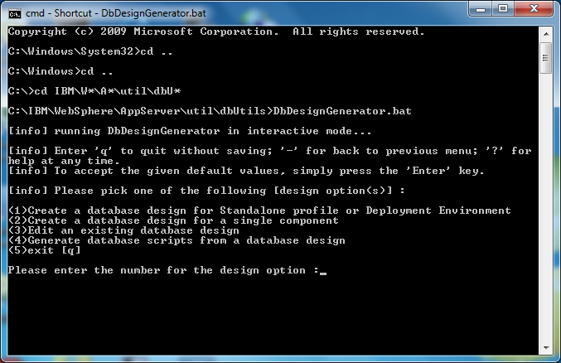

1. Select option 1 and press Enter:

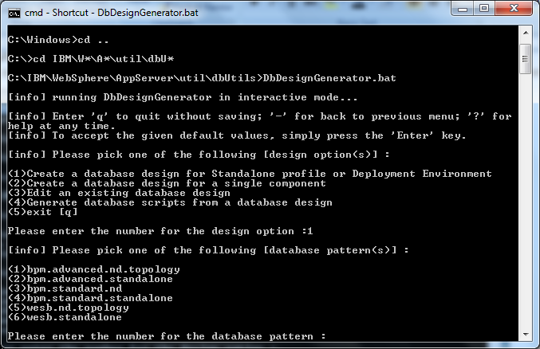

1. Select Option 1 and press Enter:

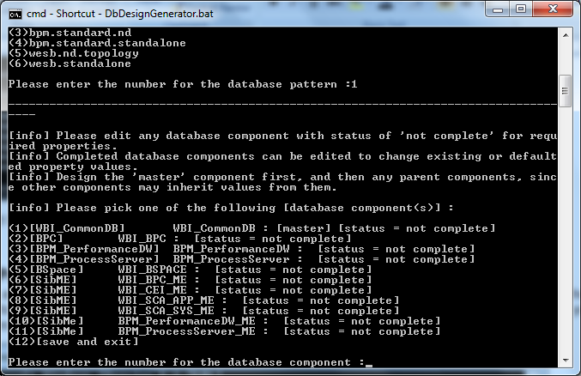

1. Again, select Option 1 and press Enter. You can see that there are status notifications telling you which sections of the database script creation are complete or not complete. You will want to make sure these all say complete in the end:

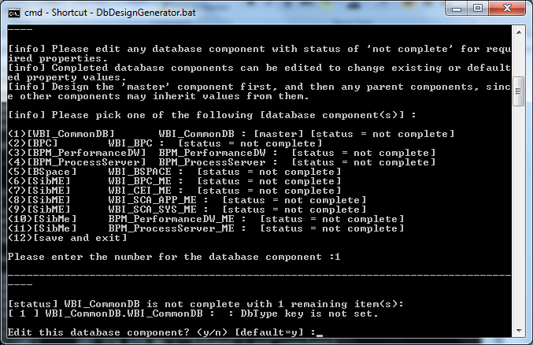

1. Enter ‘y’ press Enter:

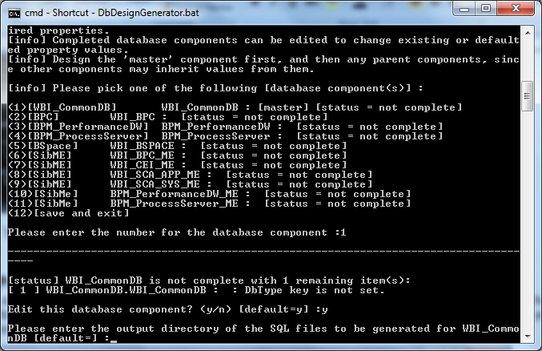

1. Press Enter to select the default:

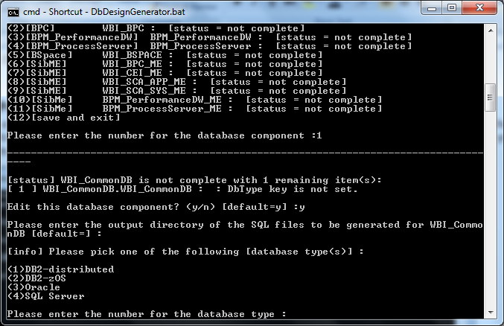

1. Select option 1 and press Enter:

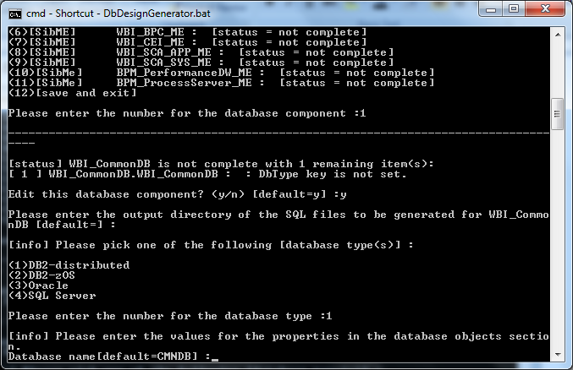

1. Select the default option by pressing Enter:

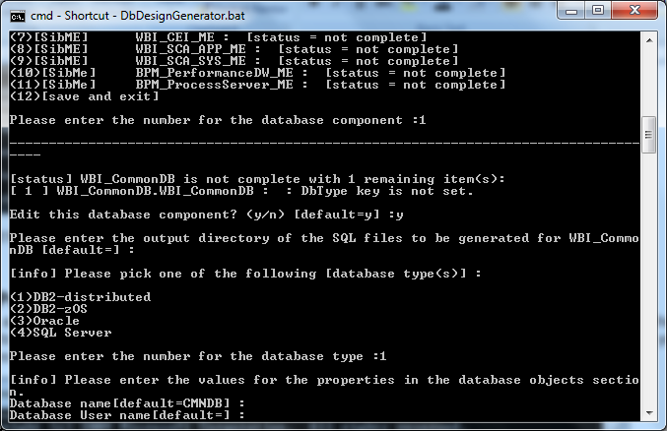

1. Enter the ID you created in Part 1 that will be accessing the databases. Press Enter:

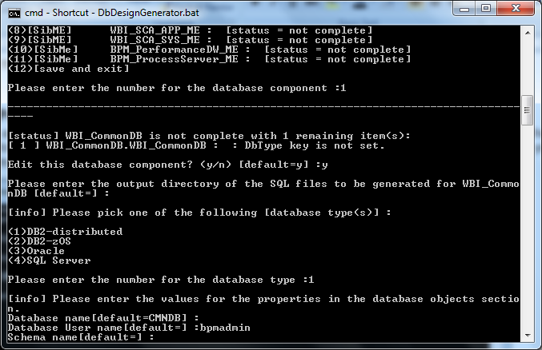

1. Press Enter to take the default schema name:

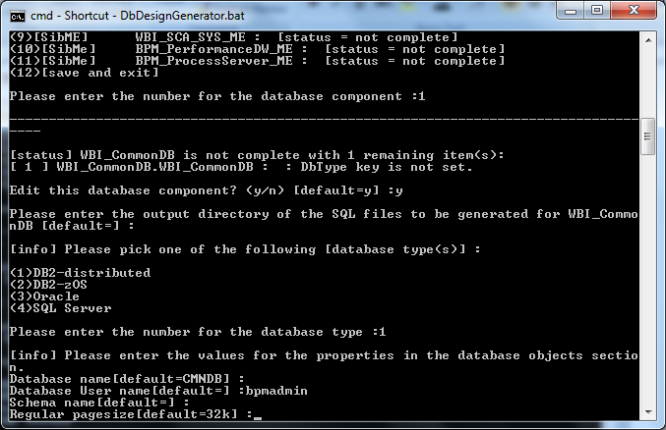

1. Again, press Enter to take default:

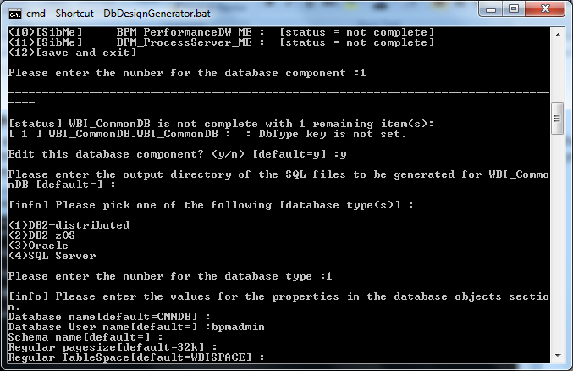

1. Press Enter to take default:

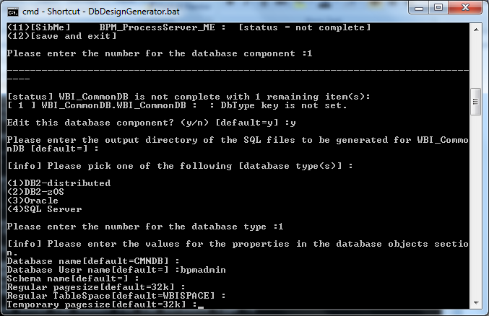

1. Press Enter to take default:

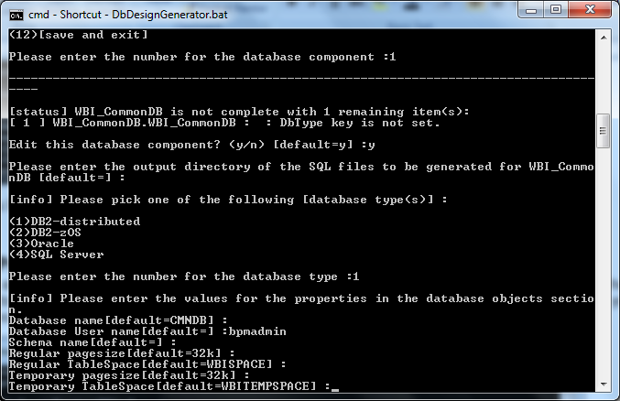

1. Press Enter to take defaults:

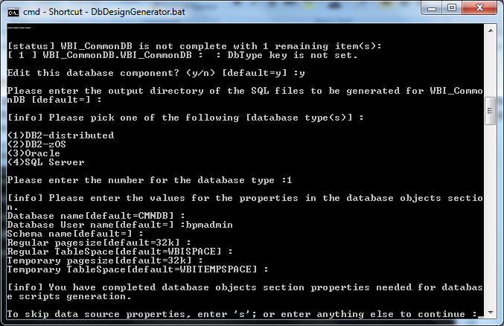

1. Press Enter to take default:

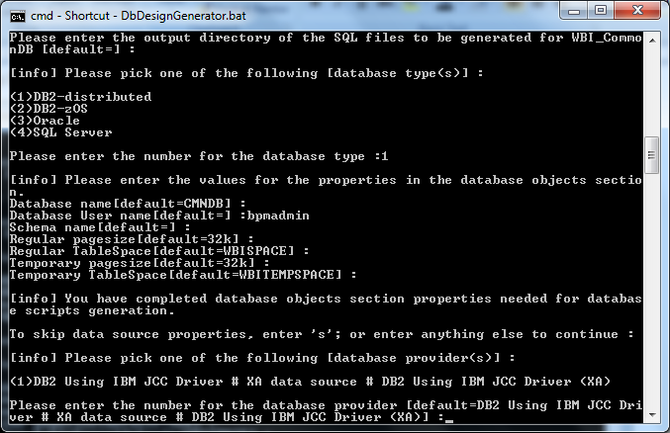

1. Press Enter to take default:

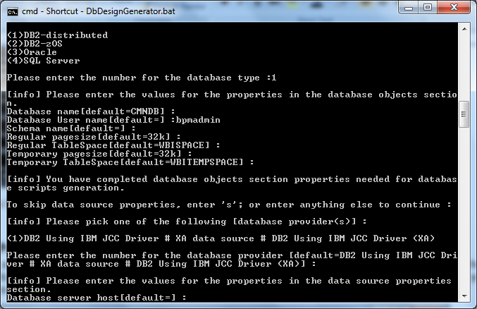

1. Enter the name of your host machine (i.e. your laptop or desktop computer name), and press Enter:

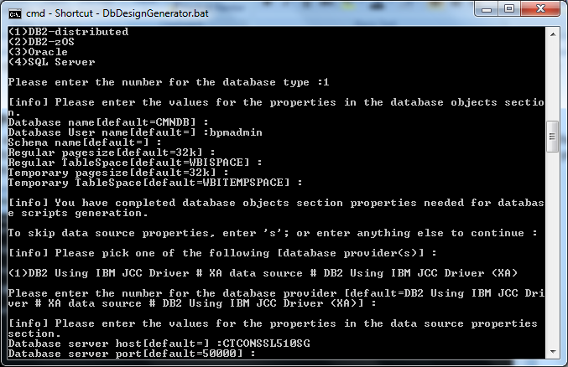

1. Press Enter to take default:

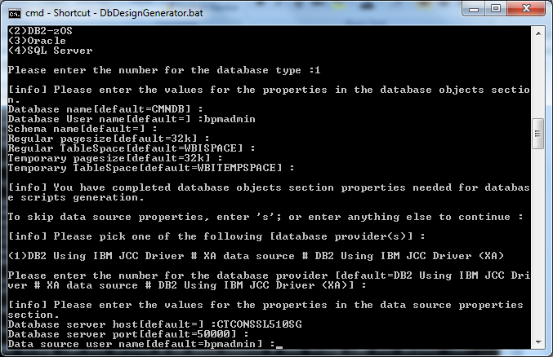

1. Ensure the ID marked as default is the ID you created in Part I. If it is, then press Enter. If it’s not, then Enter that ID and press Enter:

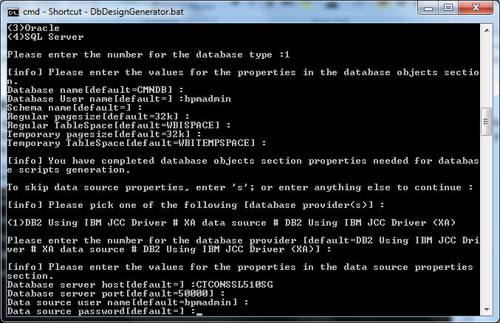

1. Enter your password for that ID and press Enter:

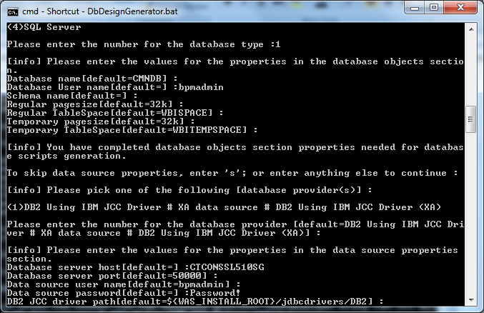

1. Press Enter for the default:

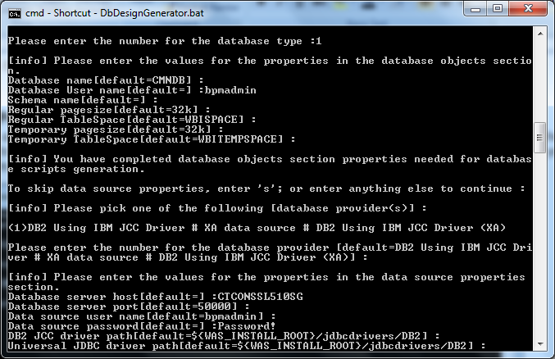

1. Press Enter to take the default:

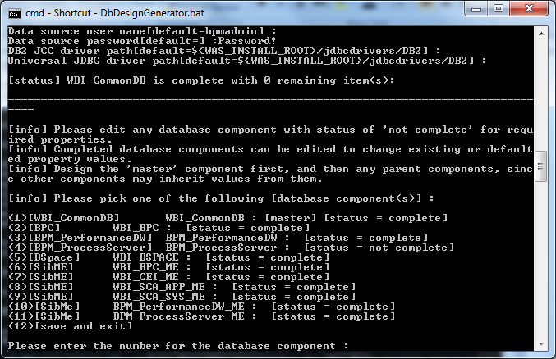

1. Notice you have now completed steps 1 – 11. Please make sure all of these steps show as complete before you proceed. Enter option 12 to save the information:

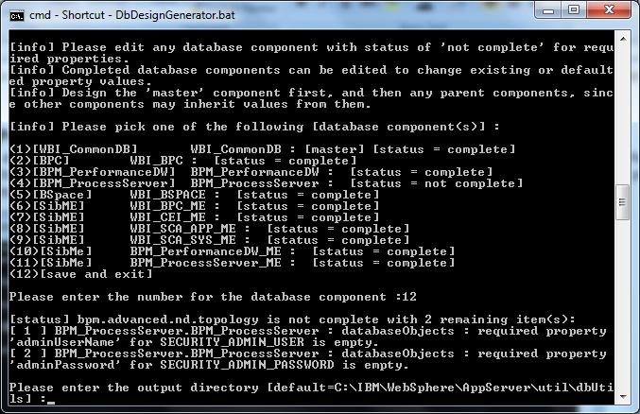

1. Press Enter to take the defaults:

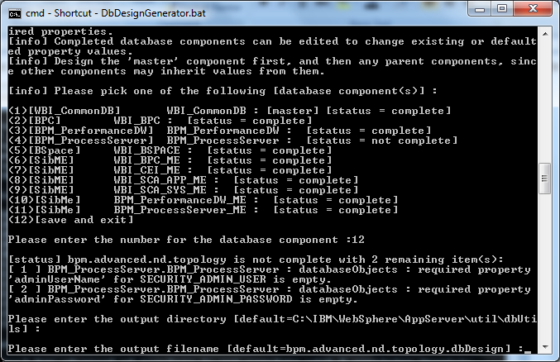

1. Press Enter to take defaults:

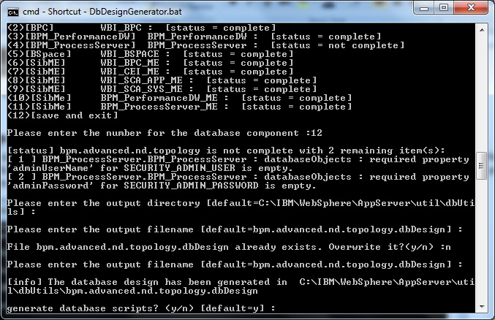

1. Press Enter to take default:

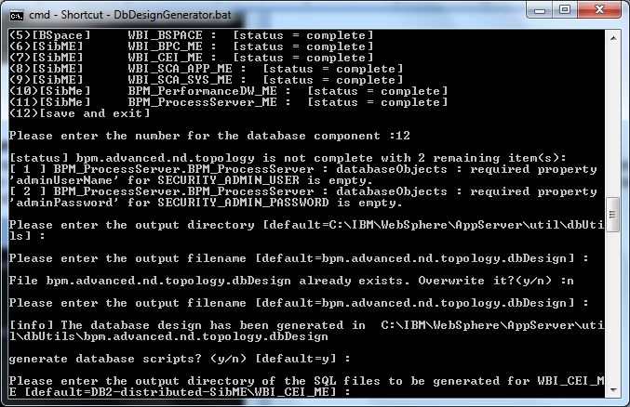

1. Press Enter to take default:

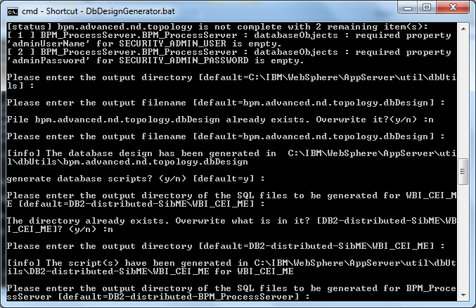

1. Press Enter and take the default:

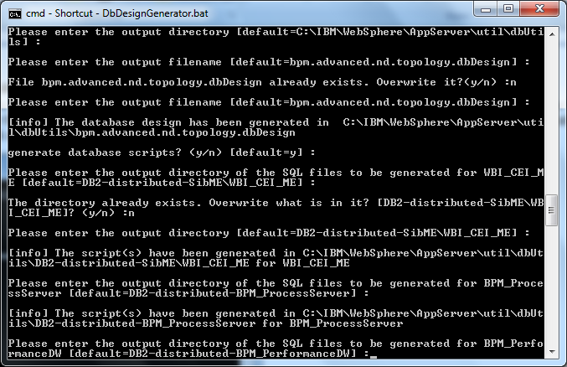

1. Press Enter and take defaults:

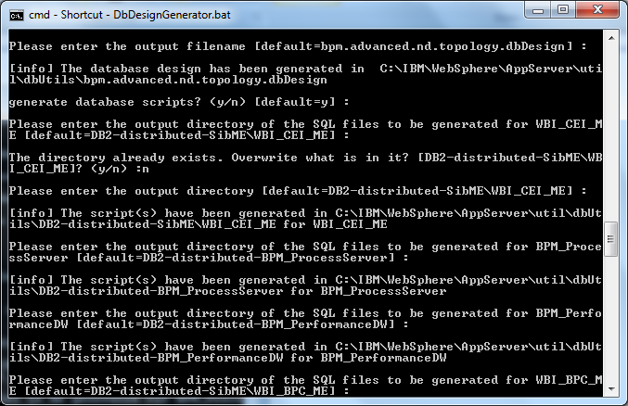

1. Press Enter and take default:

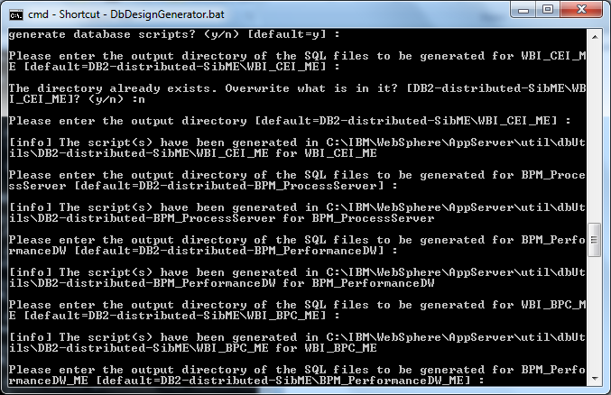

1. Press Enter and take default:

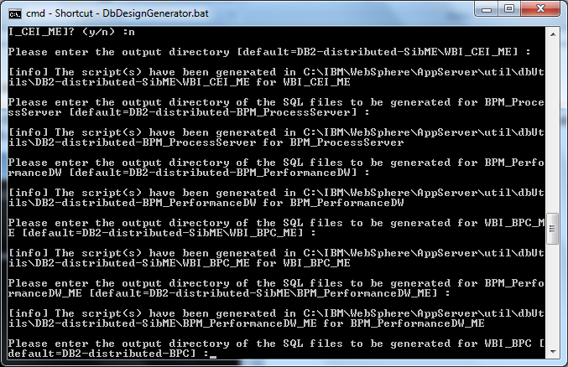

1. Press Enter and take default:

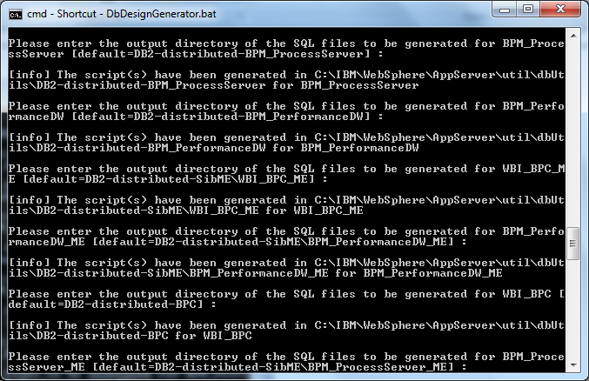

1. Press Enter and take defaults:

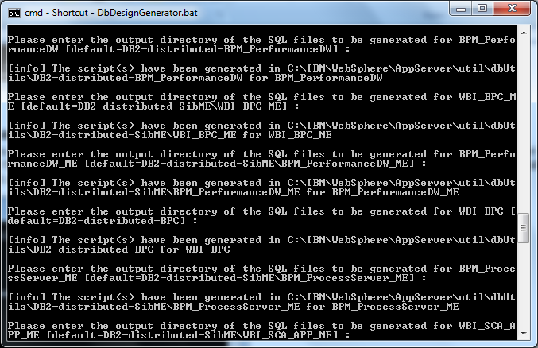

1. Press Enter and take default:

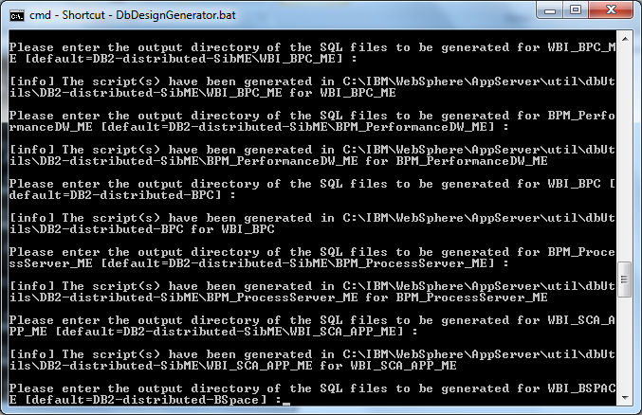

1. Press Enter and take default:

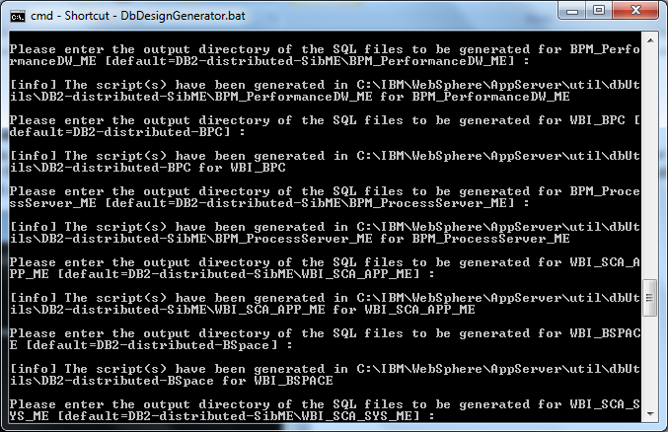

1. Press Enter and take default:

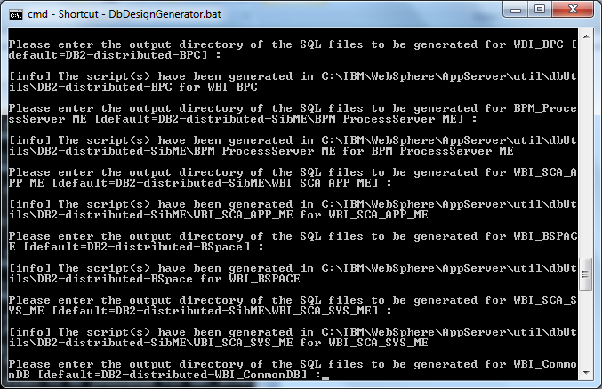

1. Press Enter and take default:

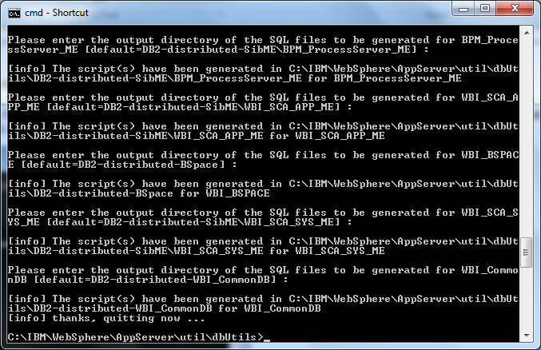

1. This concludes the database script generation. You will now see a series of scripts created in your WAS install path (i.e. C:\IBM\WebSphere\AppServer\util\dbUtils):

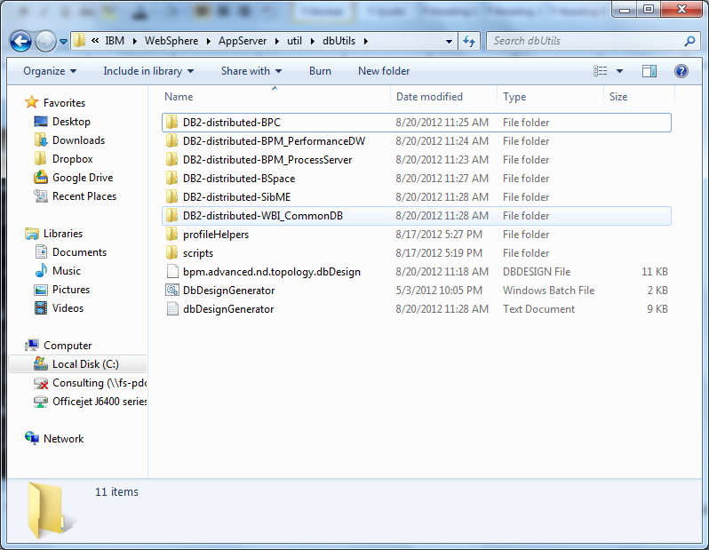

## Part IV – Database Creation

1. Before we create profiles and a deployment environment, we need to ensure, at a minimum, the databases are created. We just created the scripting that we would normally provide to our database administrator to execute and create the necessary databases and tables. However, in this situation, we are the database administrator if you are installing on your local machine. There are multiple ways to create these databases. We can: 1) create the databases using the scripting we just created (will need to have some DB2 experience and knowledge), or 2) create the databases using the DB2 Control Center and then the tables will be created when we create the deployment environment (don’t really need DB2 background).

For this exercise, I am going to assume that we do not have any DB2 experience or background. We will create the shell databases through DB2 Control Center using a GUI.

1. Prior to starting the steps below, it is best if you logoff your machine and then login to the machine using the ID you created in Part I, as this account has direct access to the database. Once you are logged in with BPADMIN, then proceed below.
2. Launch DB2 Control Center by navigating to Start>Programs>IBM DB2>DB2COPY1>General Administration Tools>Control Center. You will then be presented with the screen below. Click OK on this screen:

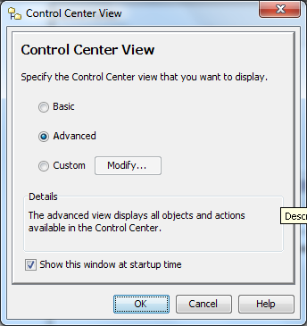

1. Here is your home screen for DB2 Control Center:

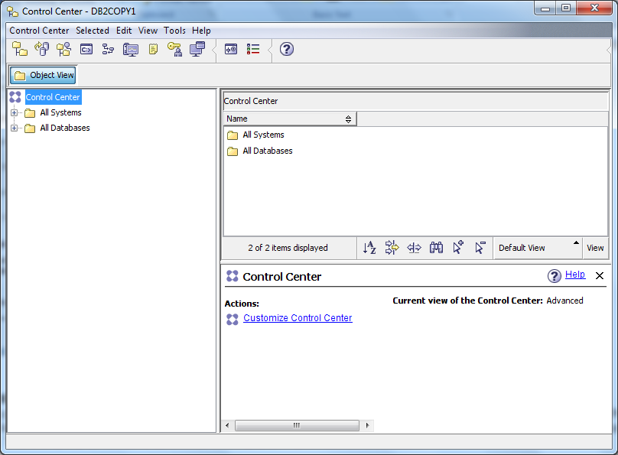

1. Expand All Systems until you reach Databases, as seen below. In my example here, I already have the three databases created. This is why you see them showing in the right pane. You will not have these shown.

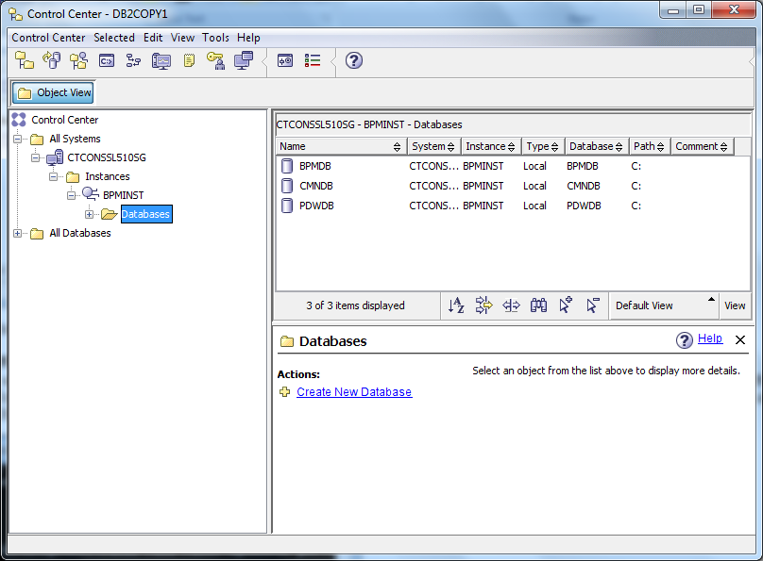

1. Right click on Databases and select Create>Standard:

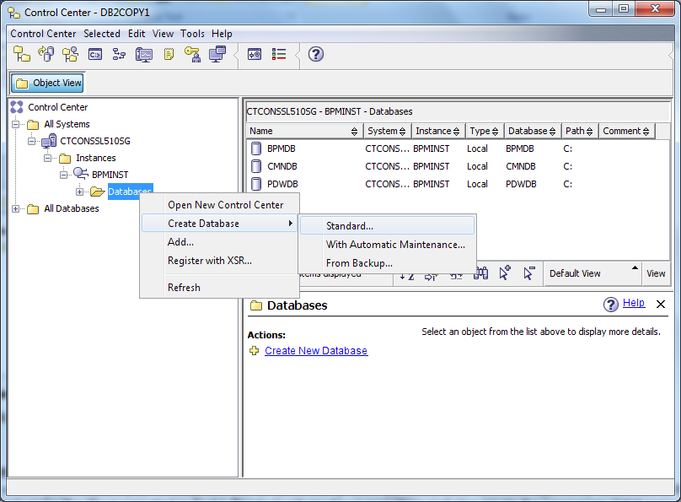

1. Enter the name of the database. There are three databases you will need to create (**BPMDB, CMNDB, PDWDB**). In my samples that I am showing below, I am creating BPMDB1, since I have already created a BPMDB. **Please make sure you name them as I have bolded above.** Enter the database name and select tablespace size of 32K. Click Next:

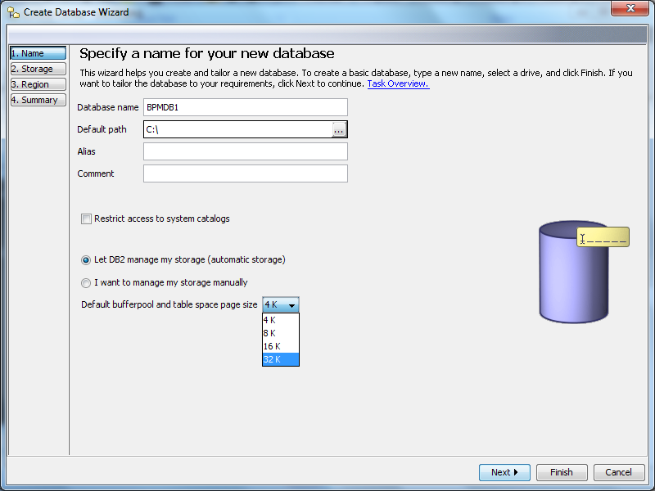

1. Press Next to take the defaults:

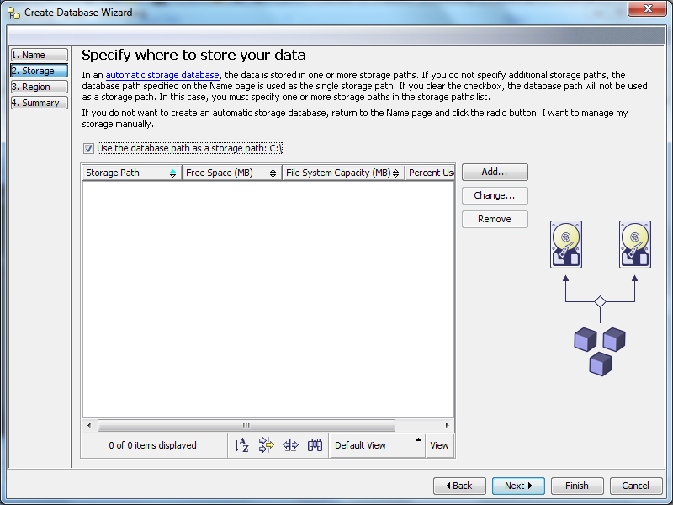

1. Ensure Territory is US and Select UTF-8 as the Code Set and click Next:

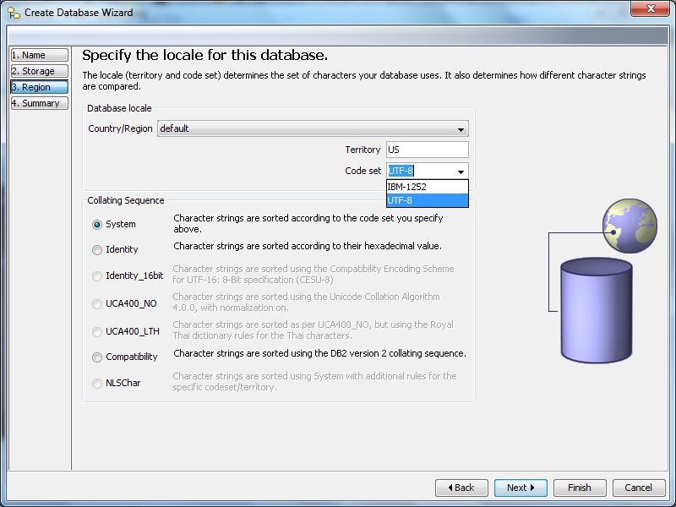

1. Review summary and click Finish:

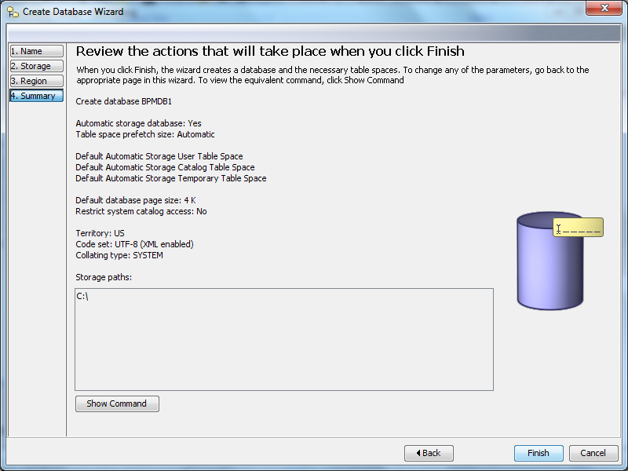

1. Look for the successful creation screen below. **Repeat steps 7-10 for the remaining two databases**. You should have three total databases created when completed: BPMDB, CMNDB, and PDWDB.

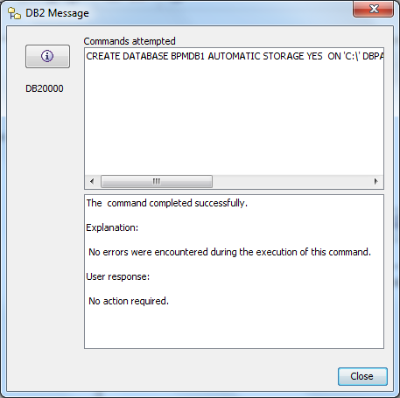

1. Once you have all three databases created as seen below, you may proceed with the setup.

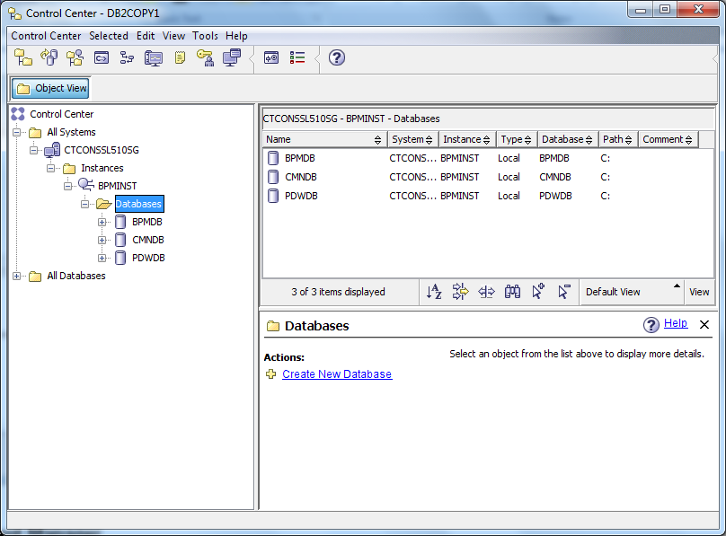

## Part V – Profile Creation – Deployment Manager

1. Open a command prompt and navigate to where you installed your WebSphere (i.e. C:\IBM\WebSphere\AppServer\bin\ProfileManagement). Now here is the important thing, you need to launch the Profile Management Tool under the ID you created in Part I. The tool will create your profiles and also create the necessary databases and tables for those profiles. Therefore, this ID needs to be a DB2ADMN and an Administrator. See below:

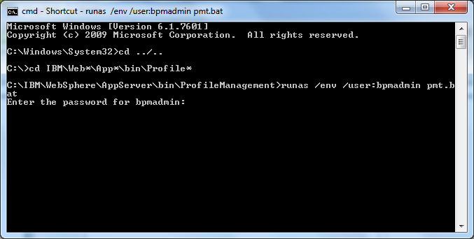

1. The Profile Management Tool is launched. Click on Create:

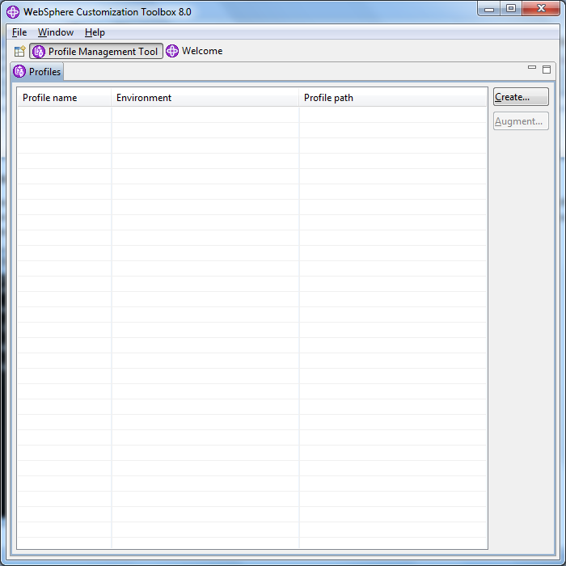

1. Here you have multiple options on what you can build for profiles. In this example, I would like to create a Network Deployment profile for BPM Advanced Process Center. (I will later create another profile for Process Server.) Click Next:

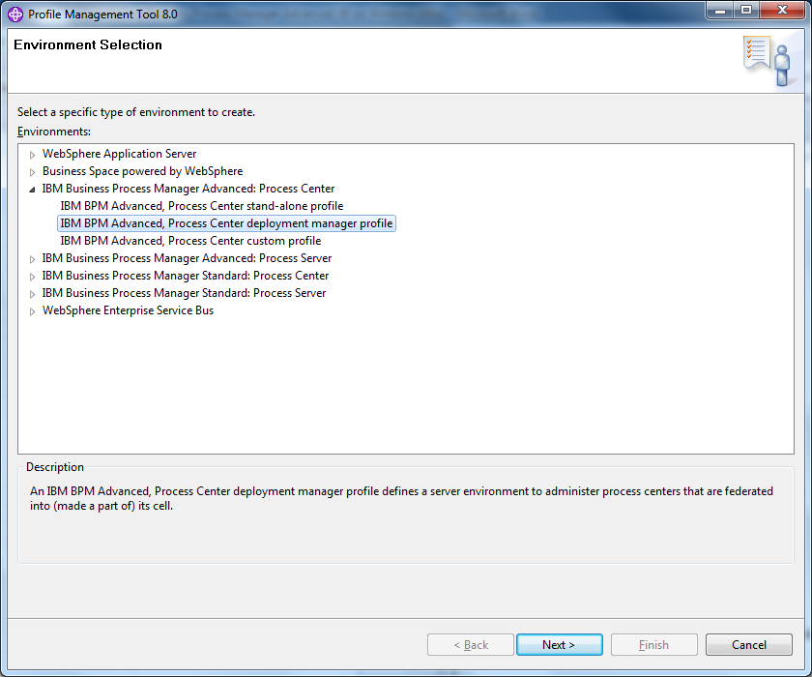

1. Select Typical profile creation, as this will usually suffice for most installations. If you wish to select your own ports, names and location of profile, etc then select Advanced. Click Next:

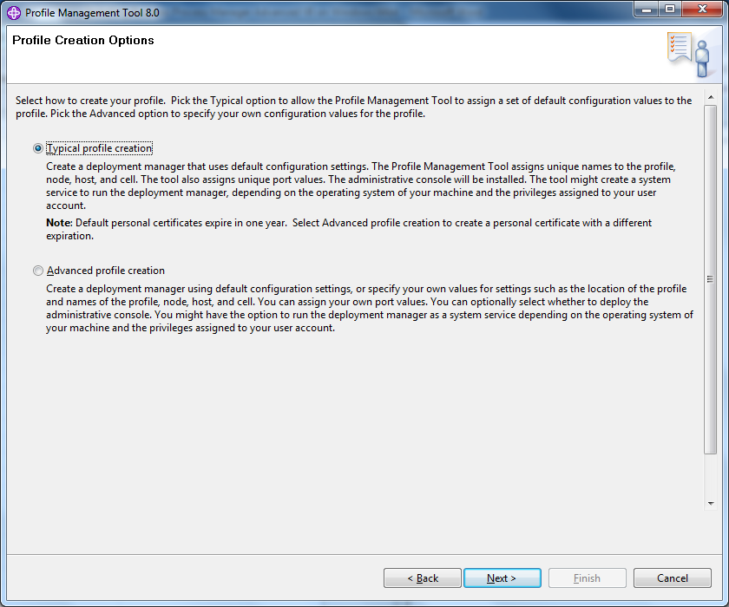

1. As security will be enabled on your WebSphere cell, you will need to provide an administrator username and password. To keep things simple, I just use the same username and password that I created in Part I. You can create a new one if you like. Click Next:

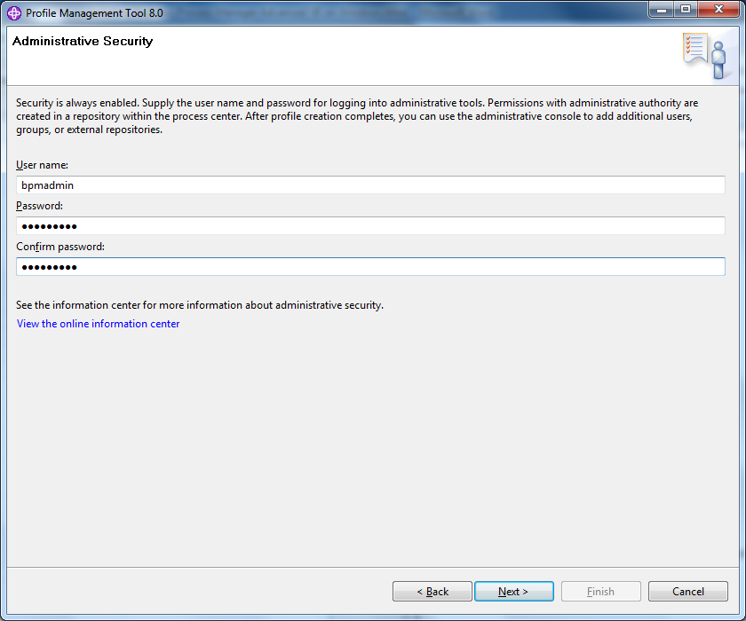

1. Keep the default options here (make sure Run database scripts to create the database tables is selected) and click Next:

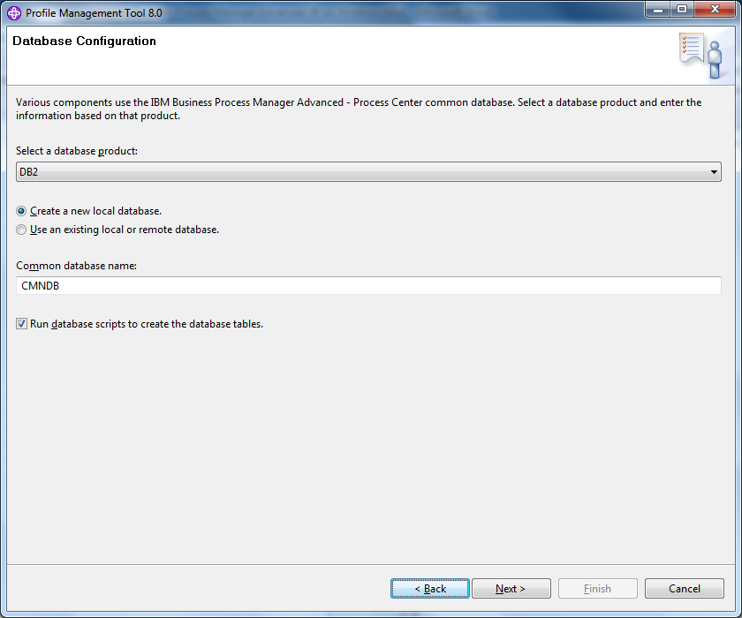

1. Enter the username and password you created in Part I and click Next:

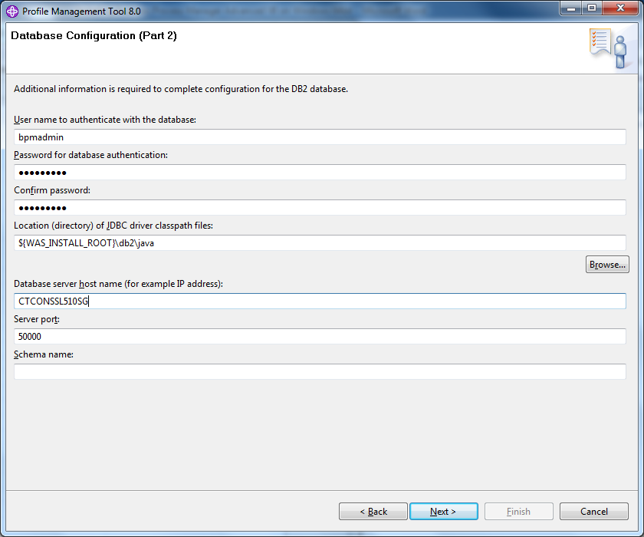

1. Review summary information and click Create:

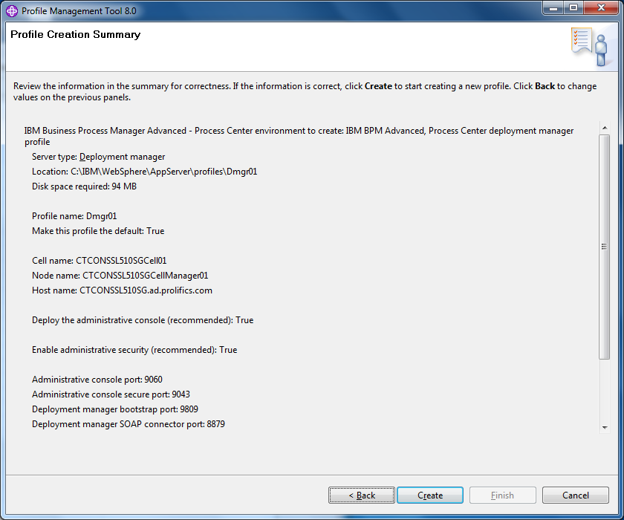

1. Looks for successful creation. Keep the Launch First Steps console checked, so you can start your Deployment Manager and verify its installation. Click Finish:

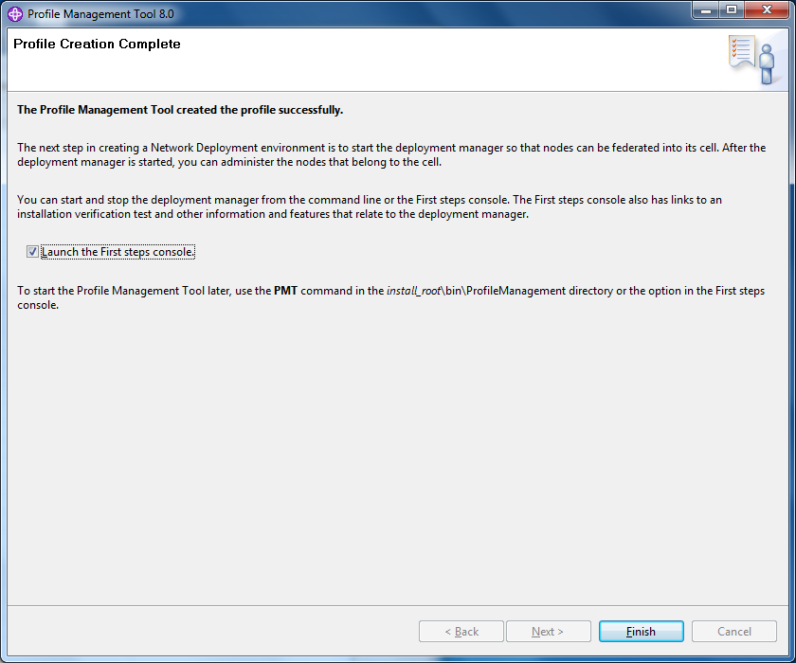

1. Click on Installation Verification:

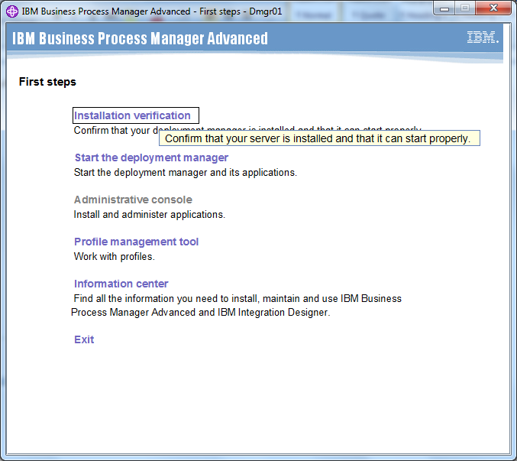

1. Look for a successful startup of your Deployment Manager and a successful verification tool execution:

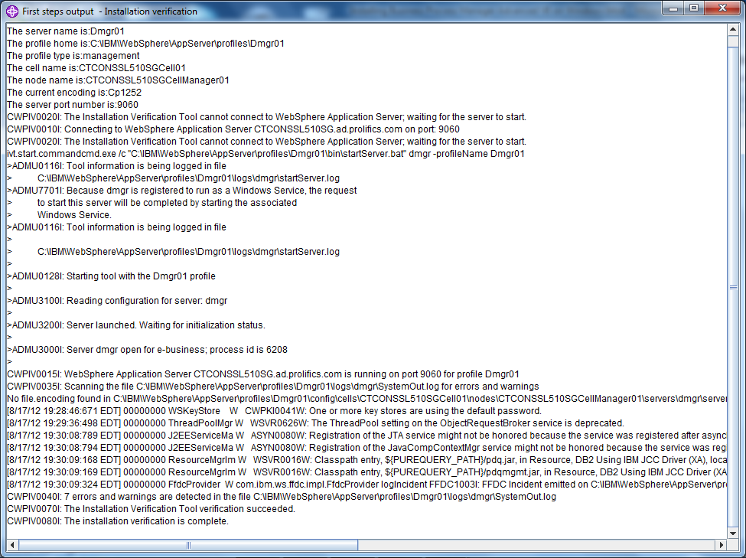

1. Close the window and Exit out of the First Steps console.

## Part VI – Profile Creation – Process Center Node

1. As in Part V, launch the Profile Management tool as seen below:



1. Click on Create (notice your DMGR is there now):

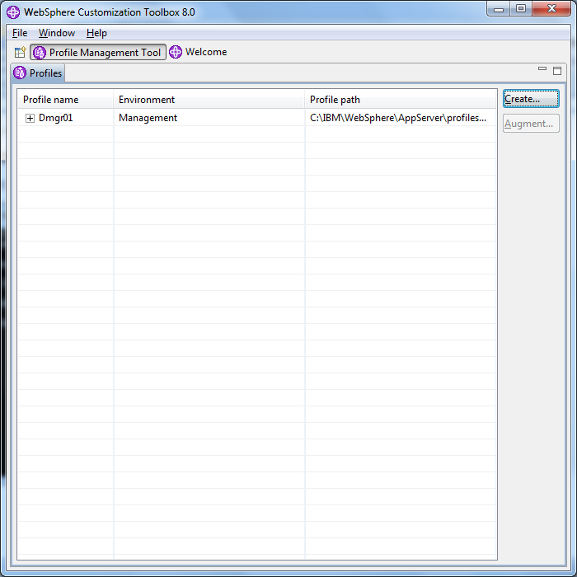

1. This time, select a custom Node for BPM Advanced Process Center. Click Next:

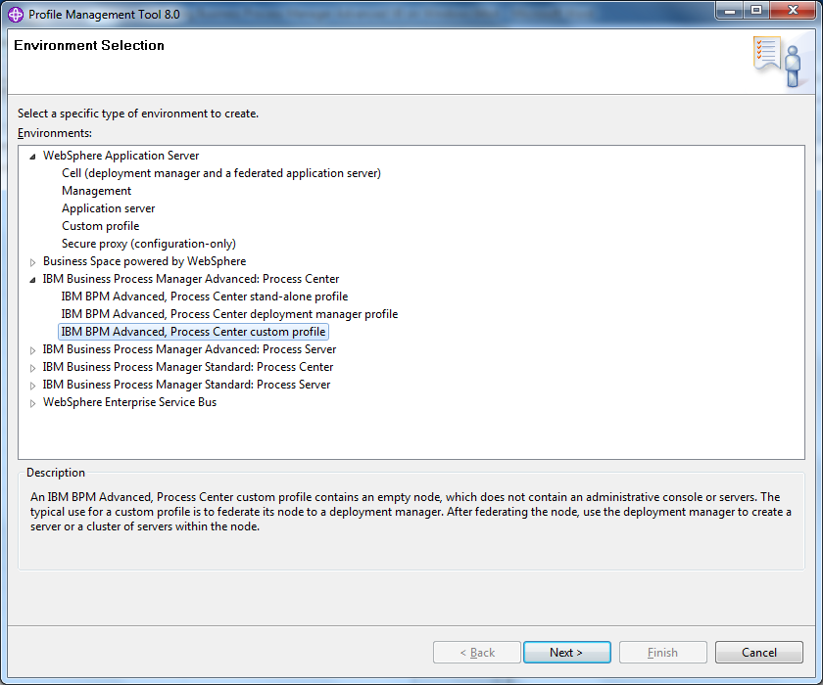

1. Typical profile creation should suffice, unless you need to customize naming, ports, etc. Click Next:

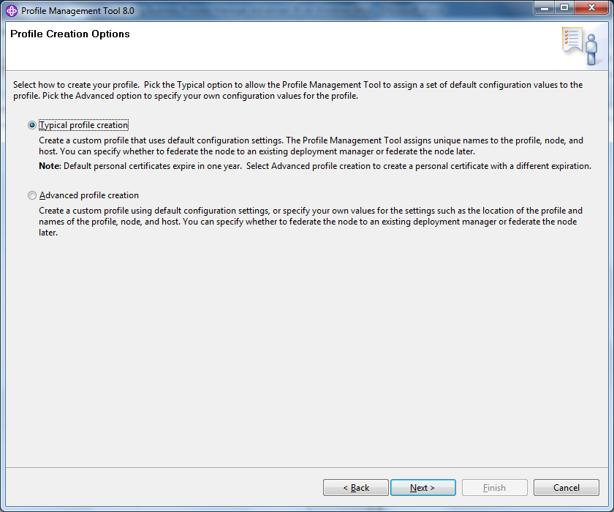

1. Keep the default settings here and just fill in your username and password that you provided for you WebSphere security. Most likely, this is the same as what you created in Part I, provided you wanted to keep everything the same. You need to ensure you DMGR is up and running before you can continue. Click Next:

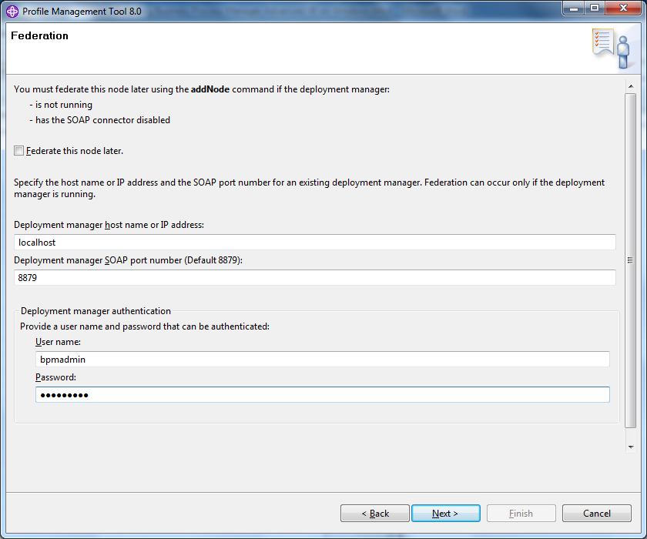

1. Again, leave the defaults and click Next:

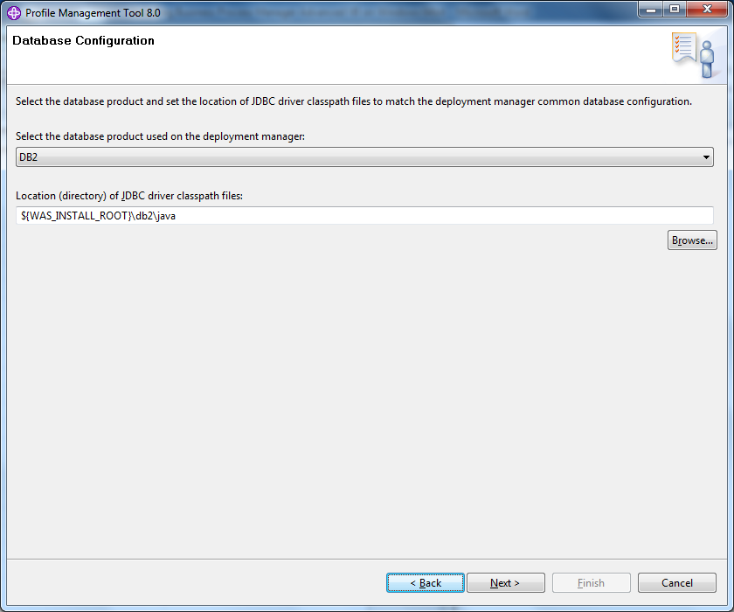

1. Review summary information and click Create:

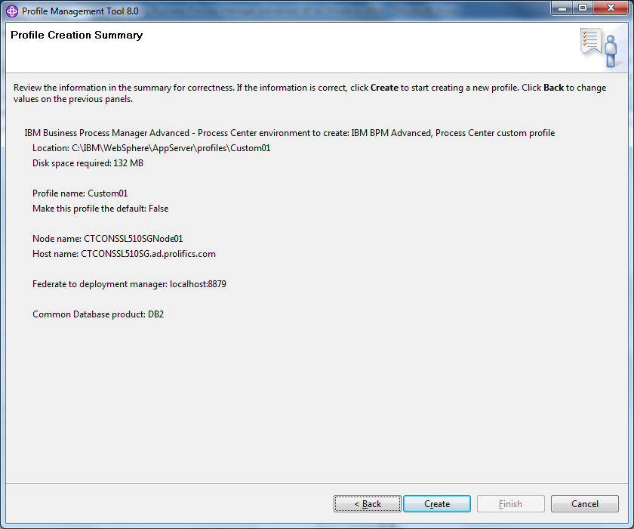

1. Look for a successful completion. You can uncheck the Launch first steps console, as there is no verification check for the nodes. Click Finish:

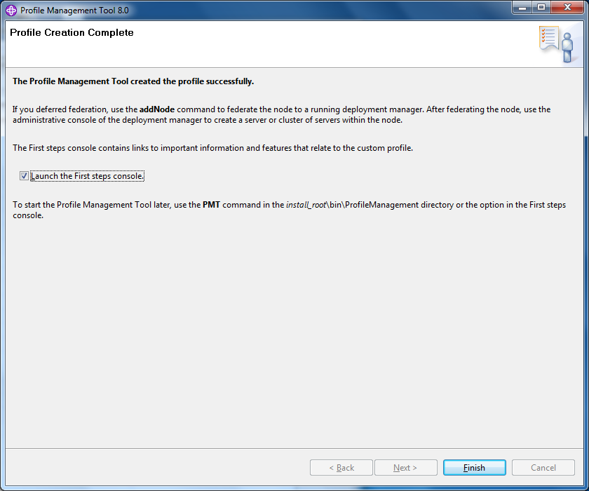

1. At this point, you can all the pieces you need for a Process Center environment. You can login (with your WebSphere admin account you previously created) to your console and check that your node agent is running and your DMGR is configured:

<https://localhost:9043/ibm/console/logon.jsp>

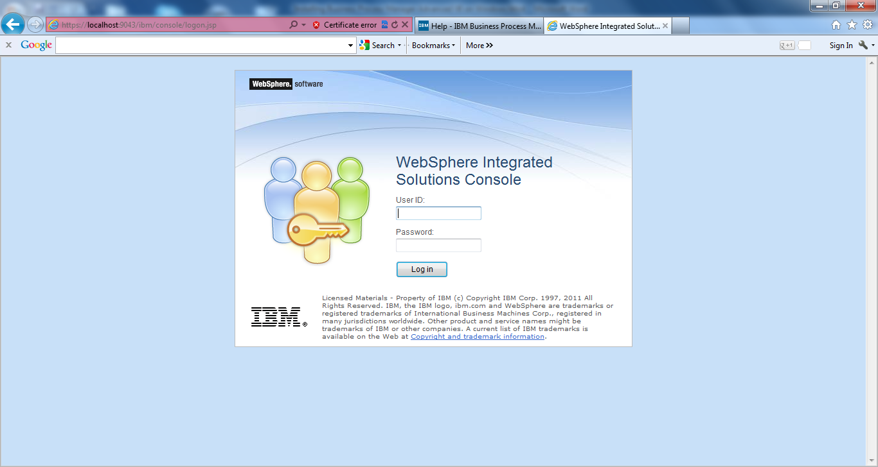

1. To create a Service to run your nodeagent (like you have for your dmgr), run the following command as an Administrator on your machine:

WASService.exe -add "Node01" -serverName "nodeagent" -profilePath "C:\IBM\WebSphere\AppServer\profiles\Custom01" -logRoot "C:\IBM\WebSphere\AppServe\profiles\Custom01\logs" -startArgs "-username bpmadmin –password Password!" -stopArgs "-username bpmadmin -password Password!" -restart false

## Part VII – Deployment Environment for Process Center

1. Login to your WebSphere Admin Console using the credentials you previously created:

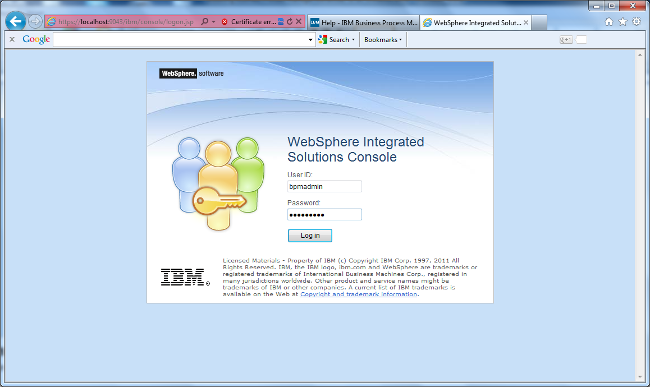

1. Navigate to Servers > Deployment Environments and then click on New:

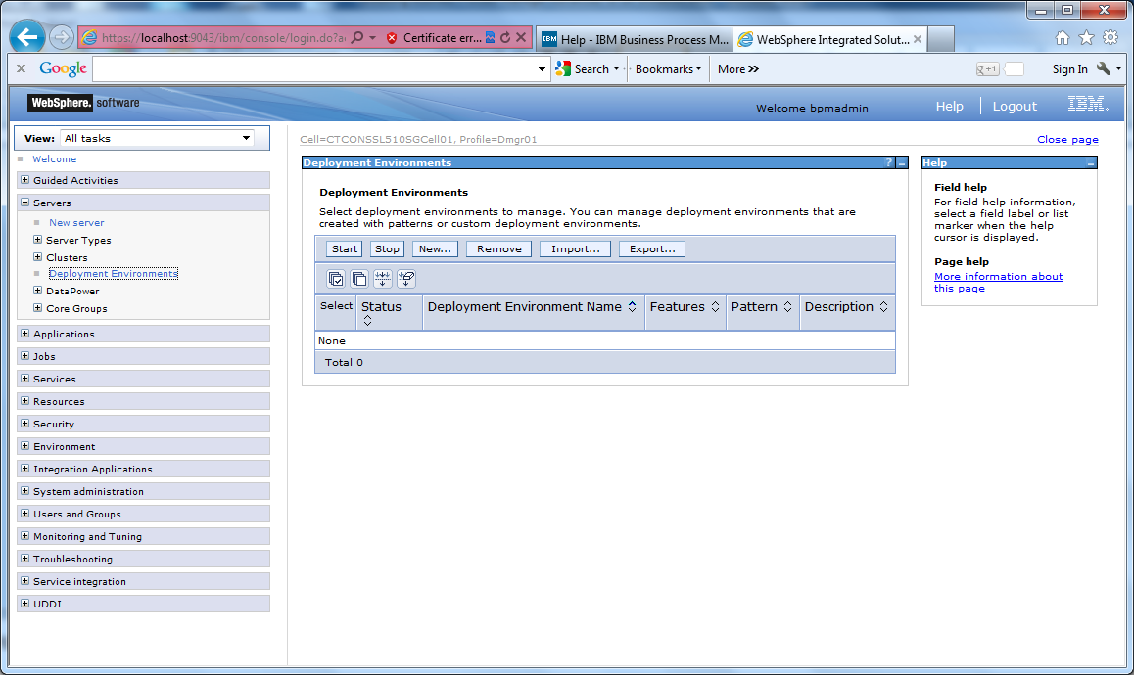

1. Make sure you select Create a deployment environment based on a pattern. Enter a name for your deployment environment. Click Next:

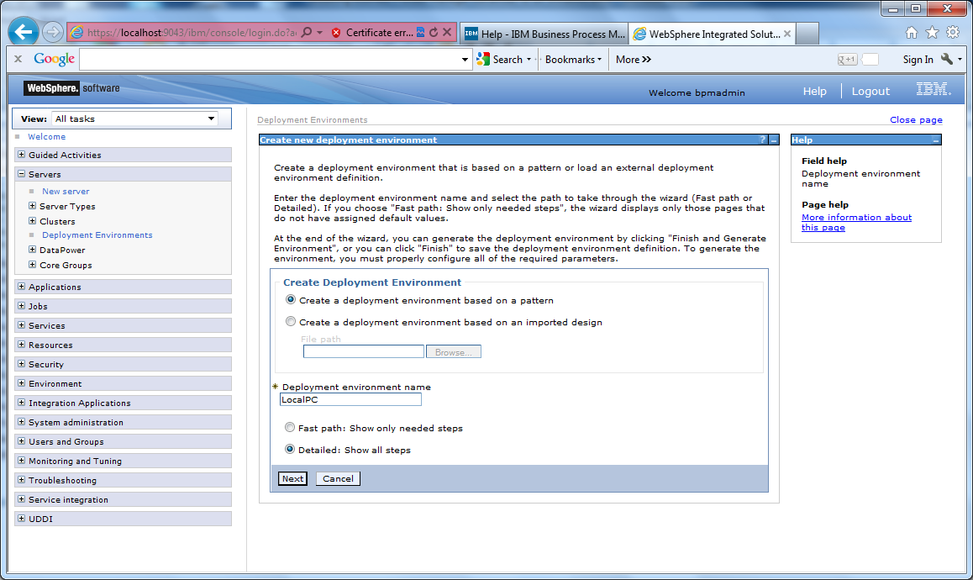

1. Select the BPM Advanced Process Center, click Next:

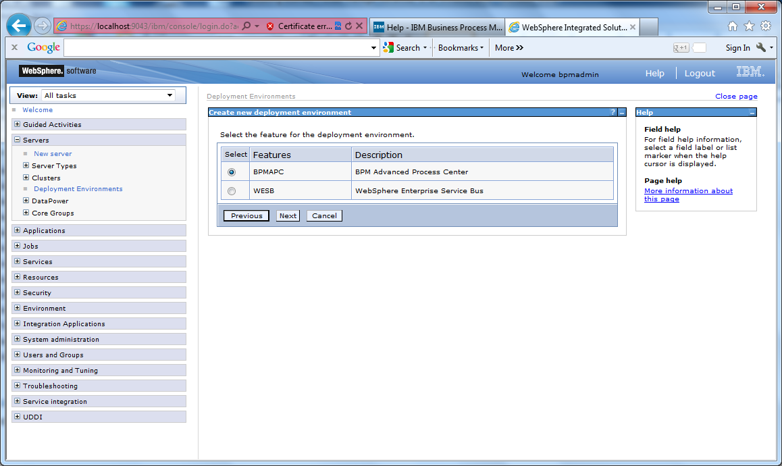

1. Select the Remote Messaging, Remote Support, and Web option and click Next:

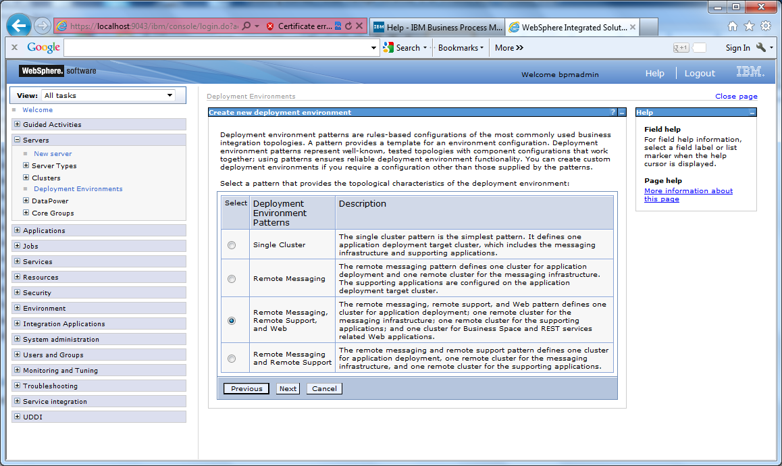

1. Select the node you previously built and click Next:

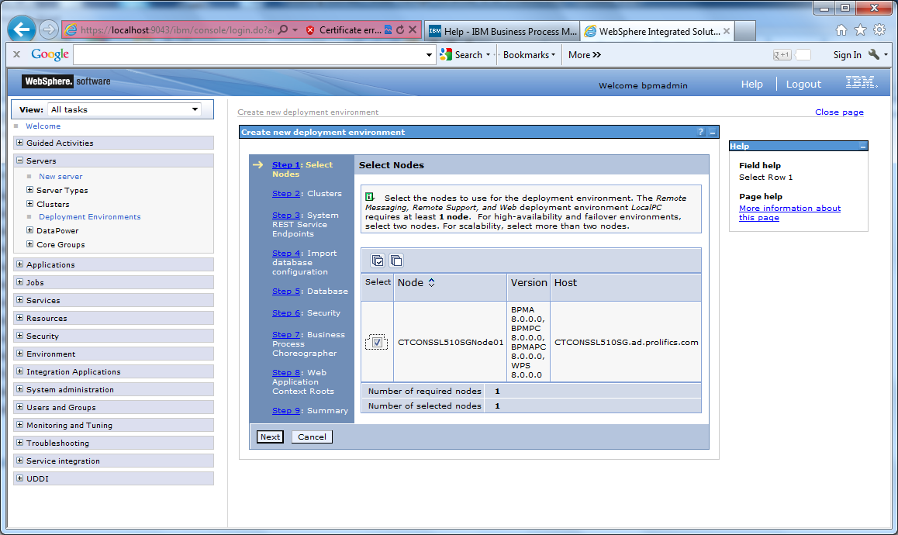

1. Keep the default for cluster members and click Next:

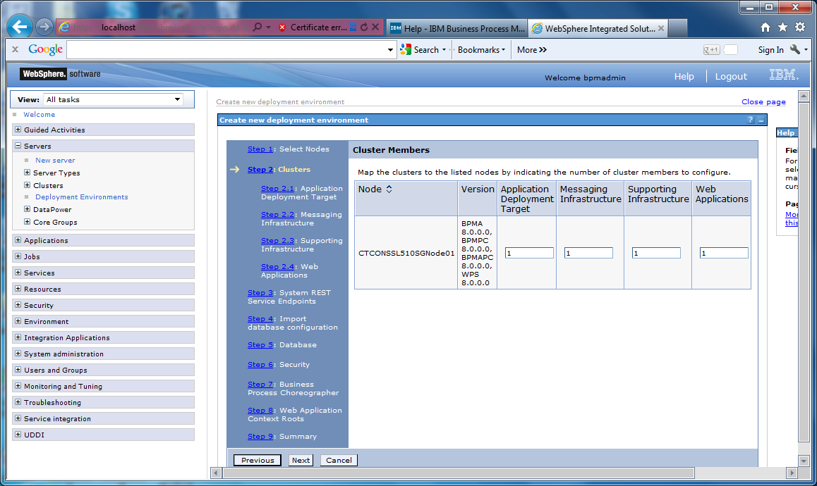

1. Keep defaults and click Next:

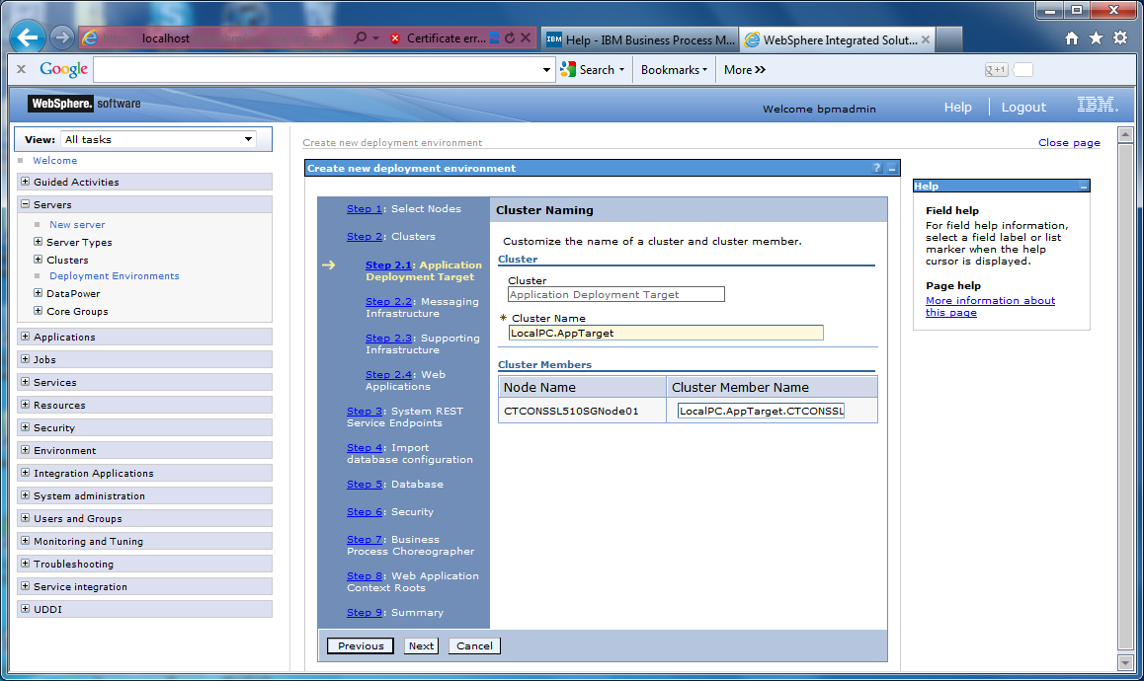

1. Keep defaults and click Next:

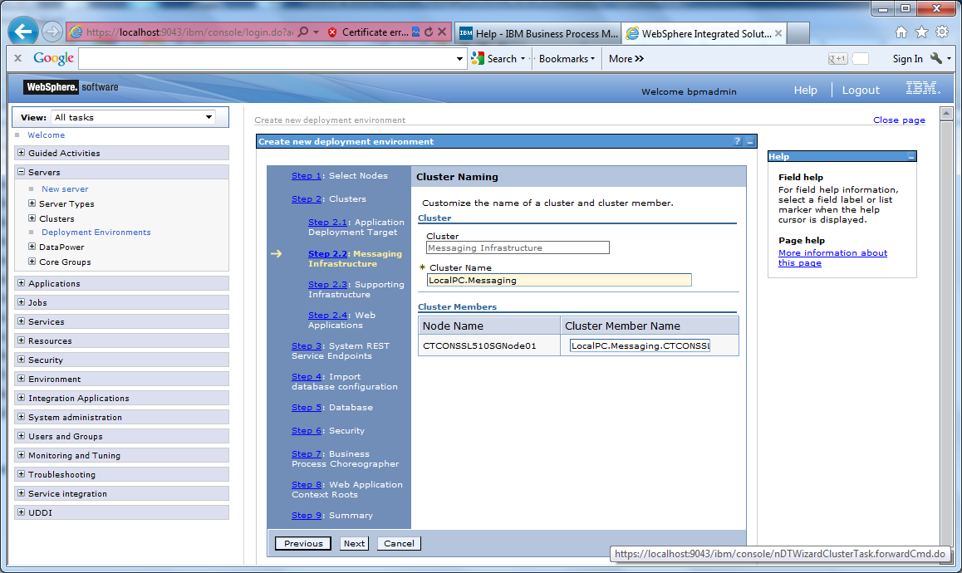

1. Keep defaults and click Next:

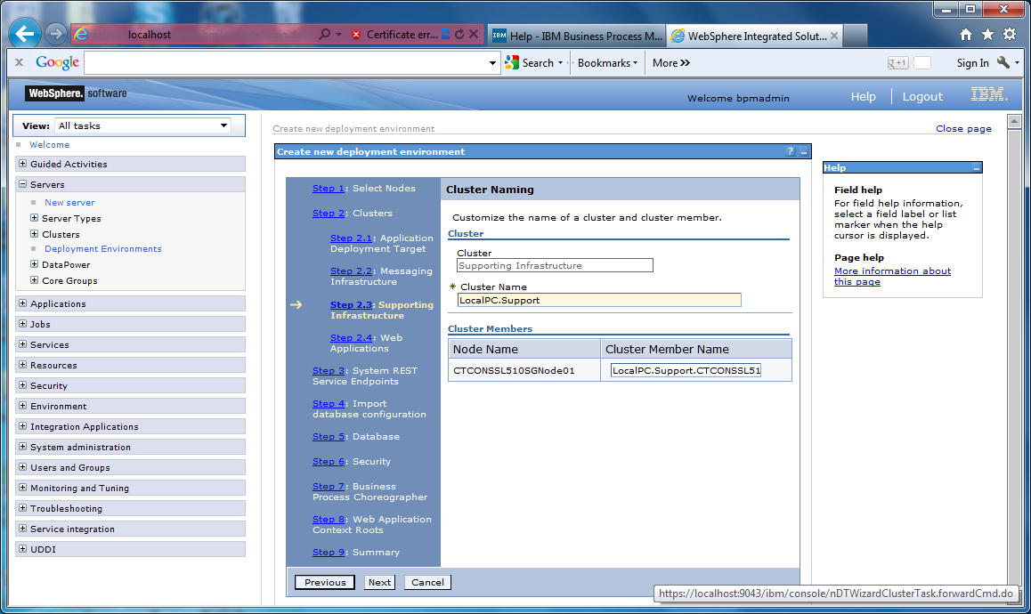

1. Keep defaults and click Next:

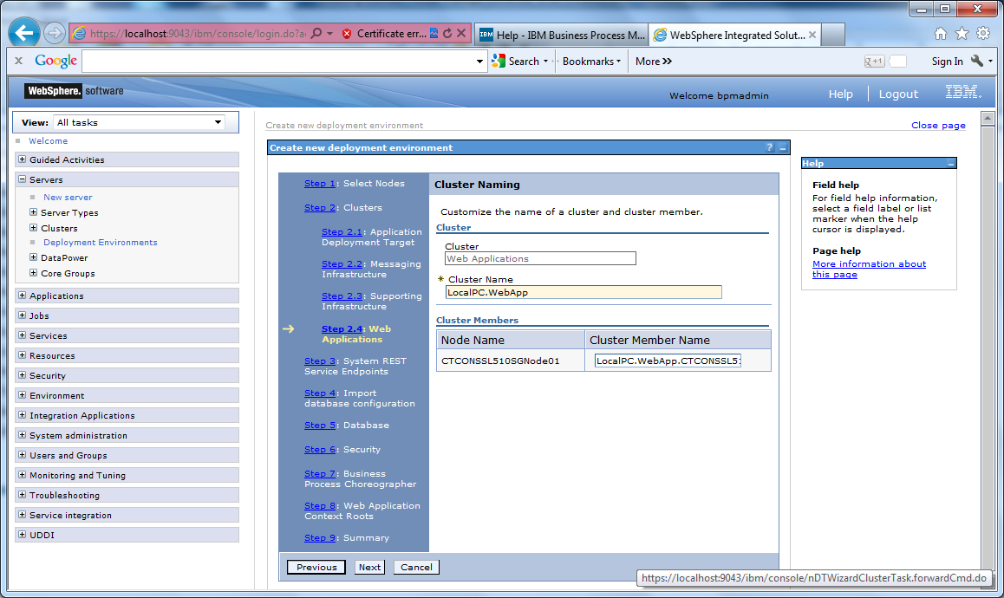

1. Keep defaults and click Next:

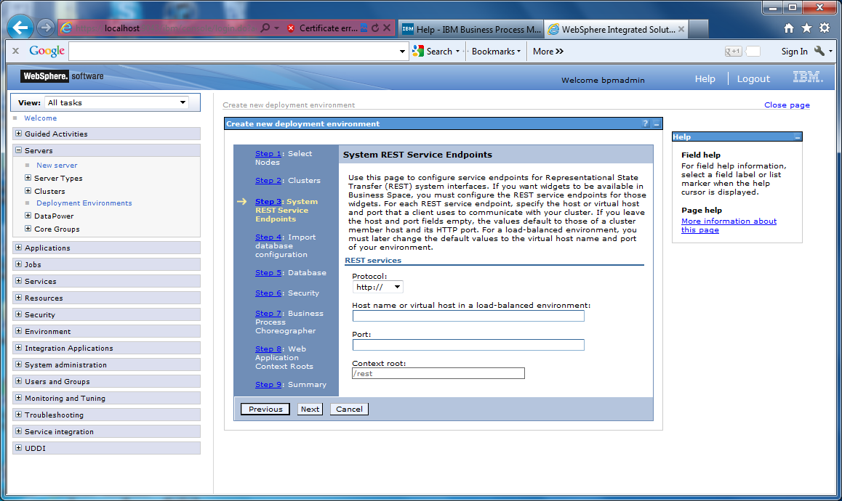

1. Click Next

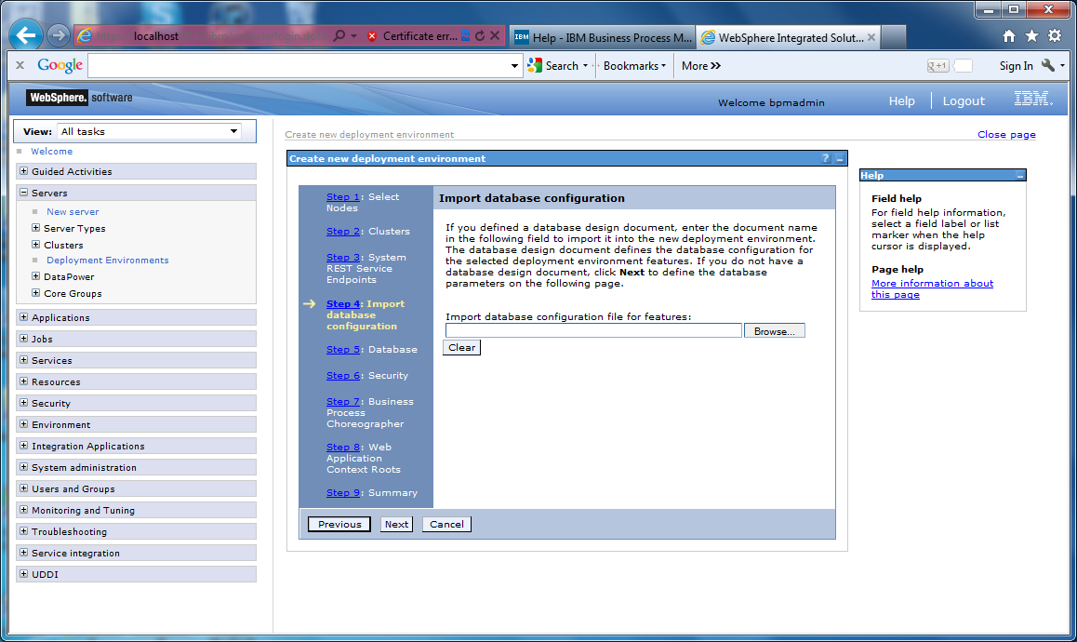

1. Keep defaults. Make sure Create tables is selected for all rows. Click Next:

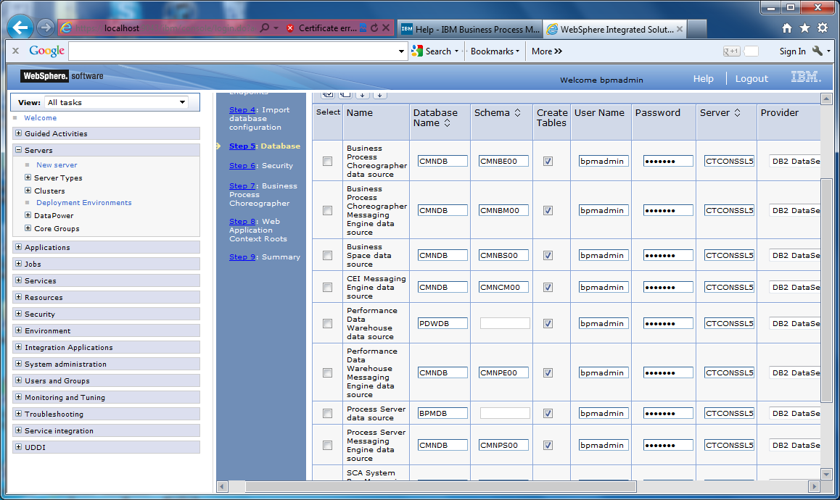

1. Again, keep defaults, and click Next:

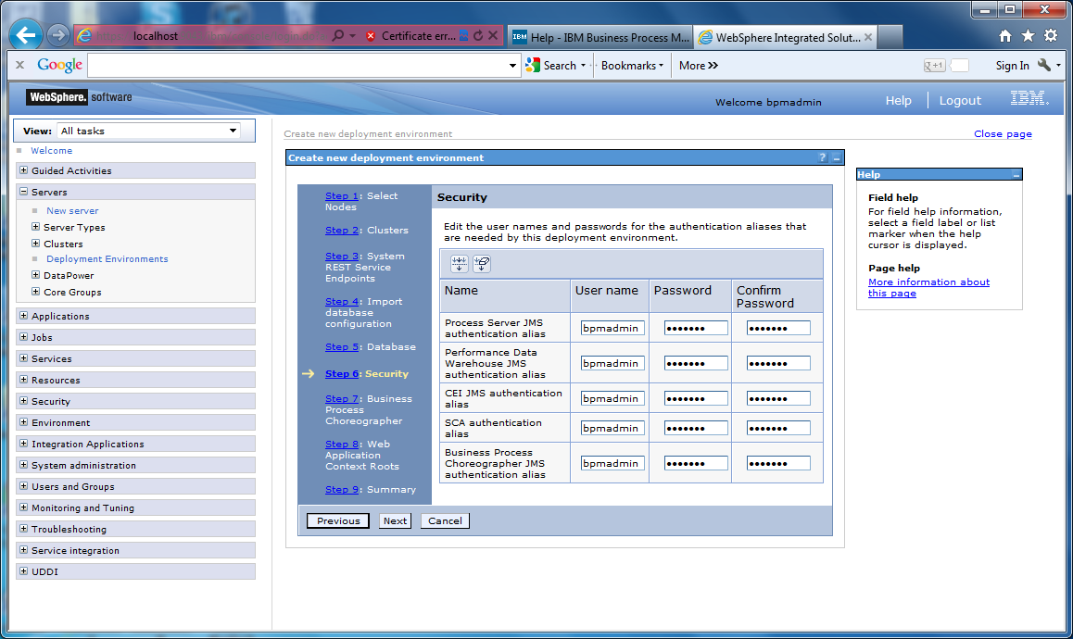

1. Enter the password for the bpmadmin user you previously created. Keep all other defaults and click Next:

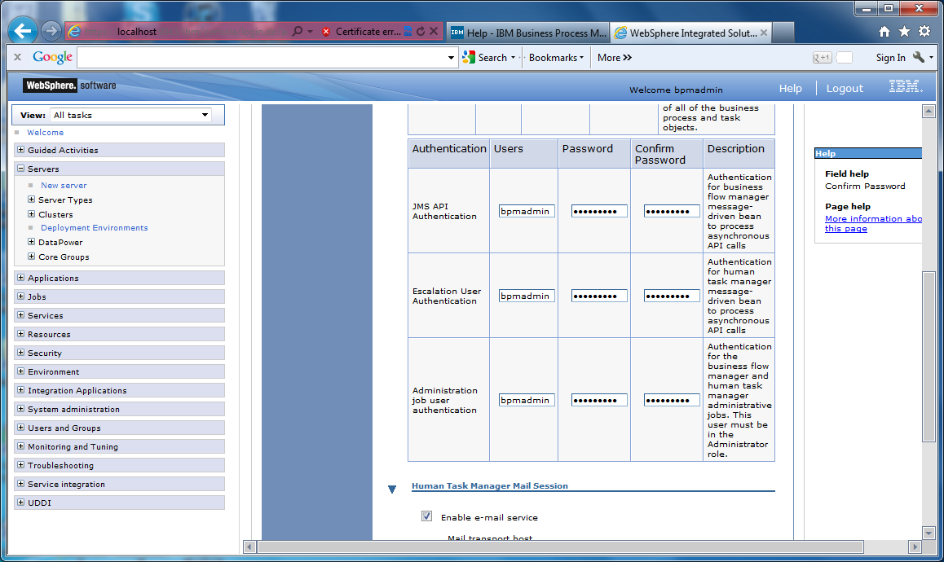

1. Keep defaults and click Next:

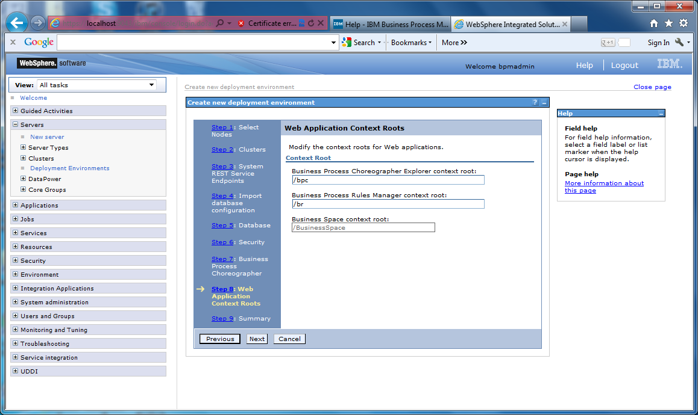

1. Review summary and click Finish and Generate Environment:

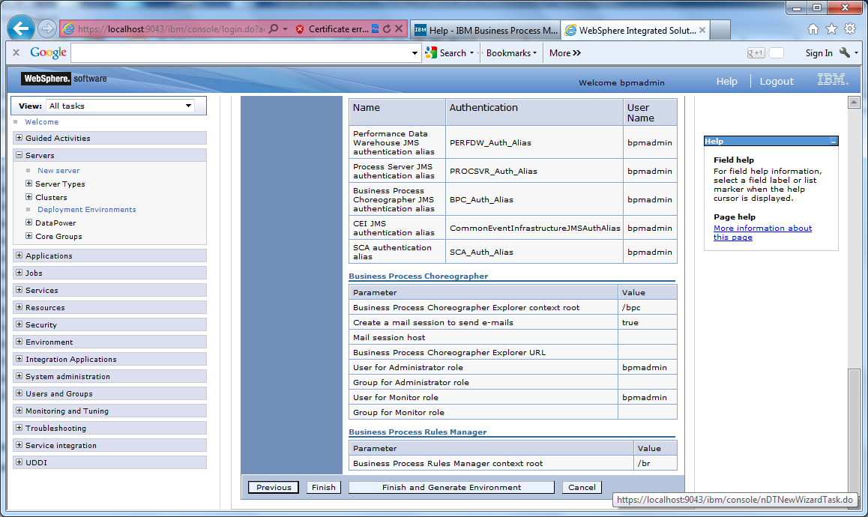

1. Look for successful creation of your deployment environment. Click Save Changes:

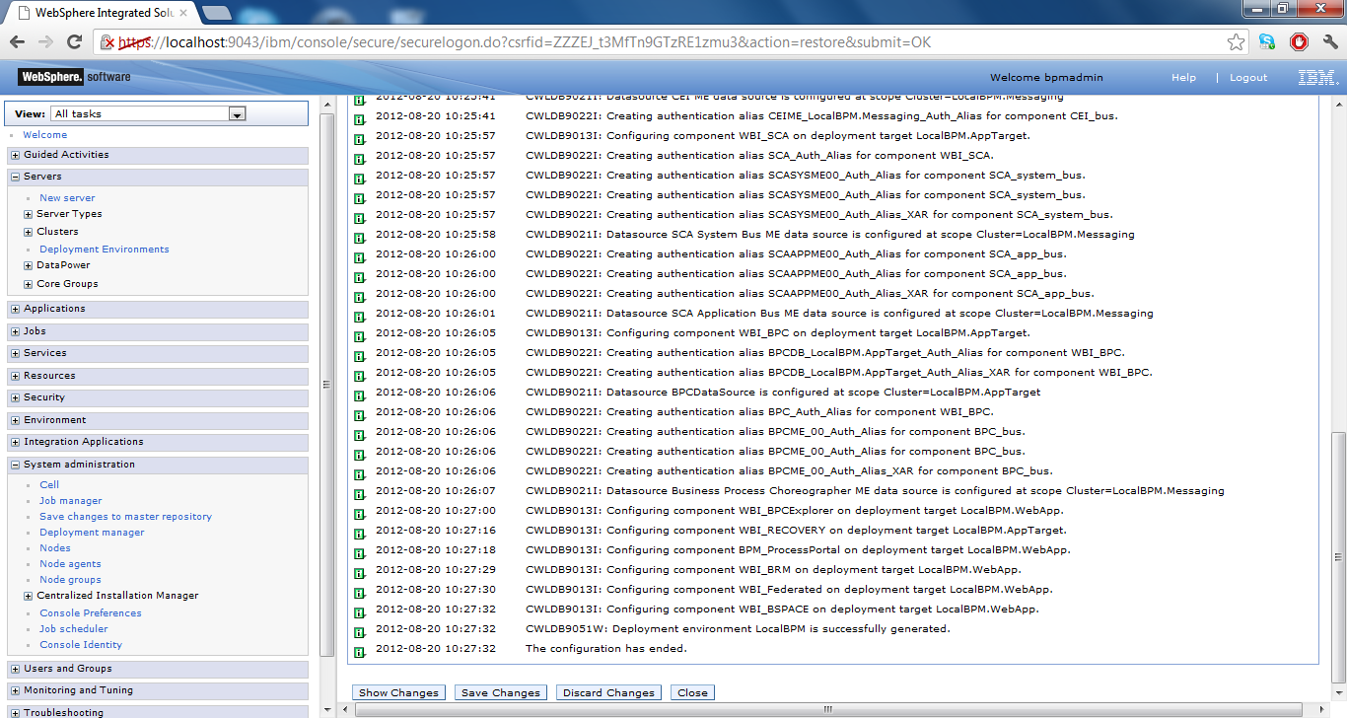

1. Verify that your deployment environment is now present (will show as unavailable as all the servers are down at this time):

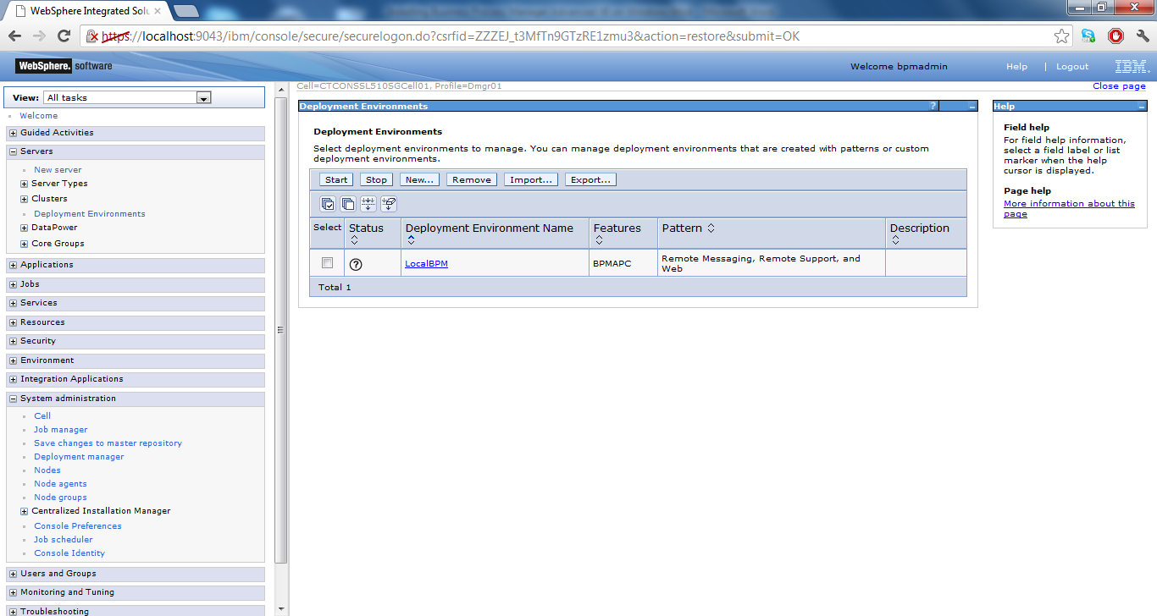

1. You will now need to restart you nodeagent and deployment manager. You can do this through Control Panel>Administrative Tools> Services. There will be two IBM Services there. Stop the Node first, then stop the DMGR. Then start the DMGR and then start the Node.

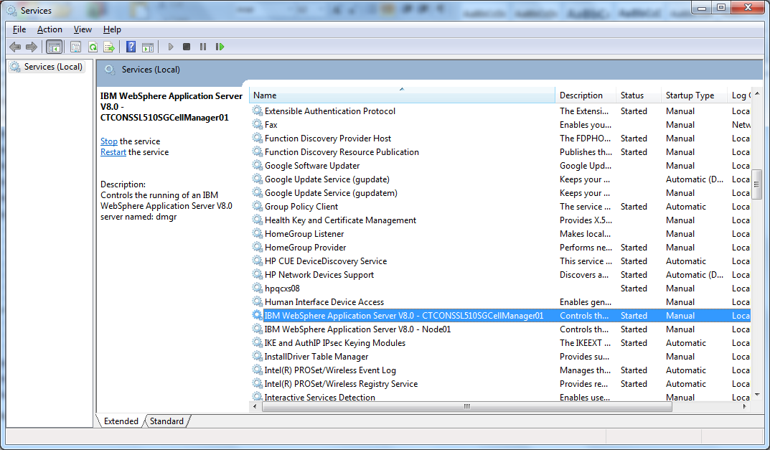

1. After your deployment manager and nodeagent are back up and running, log back into your deployment manager.

<https://localhost:9043/ibm/console/logon.jsp>

1. Navigate to Resources>JDBC>Data sources. Select all data sources and Click Test connection. You should see successful connection on all data sources. If you see a WAS_INSTALL_ROOT error below, please reference the Tip below from the IBM BPM V8 InfoCenter.

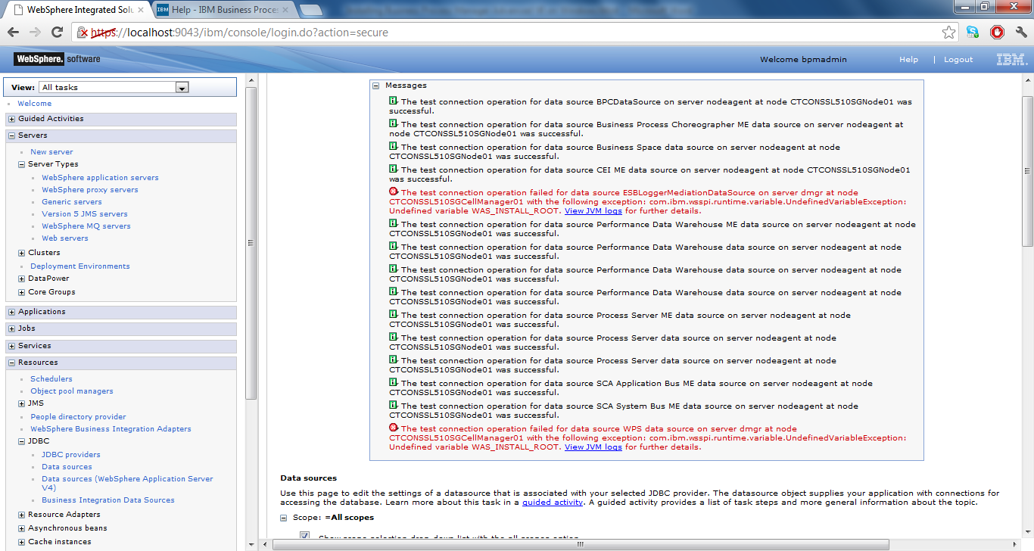

**Tip:** After you have configured a network deployment environment, if you test the data store connection (for example, in the administrative console, on the page **Resources** > **JDBC** > **Data sources**), you get a message saying that the test connection operation failed with the exceptioncom.ibm.wsspi.runtime.variable.UndefinedVariableException: Undefined Variable WAS_INSTALL_ROOT. This does not necessarily indicate that there will be a problem accessing the data source at run time. Ensure that the location of your JDBC driver files is accessible to every client that must use the data source, and configure the variable with the full path of that location. Disregard the test connection error unless you are also experiencing trouble connecting to the data store at run time. For additional information, see the WebSphere Application Server documentation about the test connection service

1. From a command prompt, navigate to C:\IBM\WebSphere\AppServer\profiles\DMGR01\bin, and execute the following command to load the database with the initial system data:

bootstrapProcessServerData.bat -clusterName LocalBPM.AppTarget

Look for the following output for a successful completion:

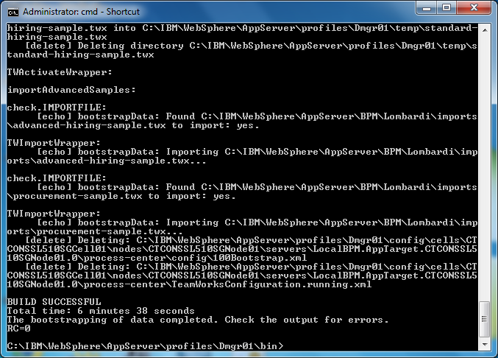

1. Log back into your WAS console and navigate to Servers>Deployment Environments>Deployment Environment Name (LocalBPM in this case)>Deferred Configuration:

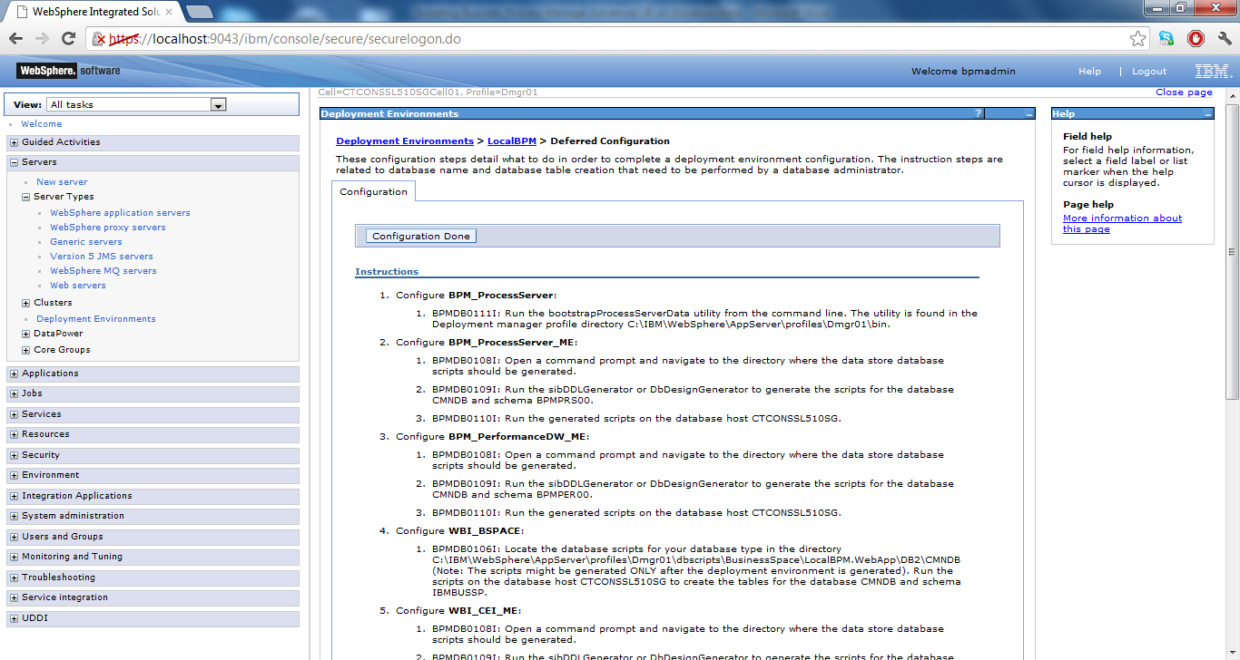

1. This screen above outlines a series of steps you will need to run against your databases. These scripts were created for you while we were running the DbDesignGenerator tool and can be located at C:\IBM\WebSphere\AppServer\util\dbUtils\DB2-distributed-SibME\. You will need to go through each of the directories in there and execute the scripting against the databases indicated in the screen above. You can execute by opening up your DB2 Control Center and navigating to the DB you want to run the script against. Right click on the database name and select Query. Then copy and paste the sql into the top portion of the screen and click on the green arrow to execute it against the database. Run through all of these scripts and ensure successful execution. Then come back to your WAS console screen above and click Configuration Done and click Save. The deployment environment should now be complete.

## Part VIII – Startup of Your Environment

1. The application servers for a BPM must be started in a certain order, as follows:
   1. LocalBPM.Messaging
   2. LocalBPM.Support
   3. LocalBPM.AppTarget
   4. LocalBPM.Web
2. Login to you WAS console and navigate to Servers>Server Types>Application Servers

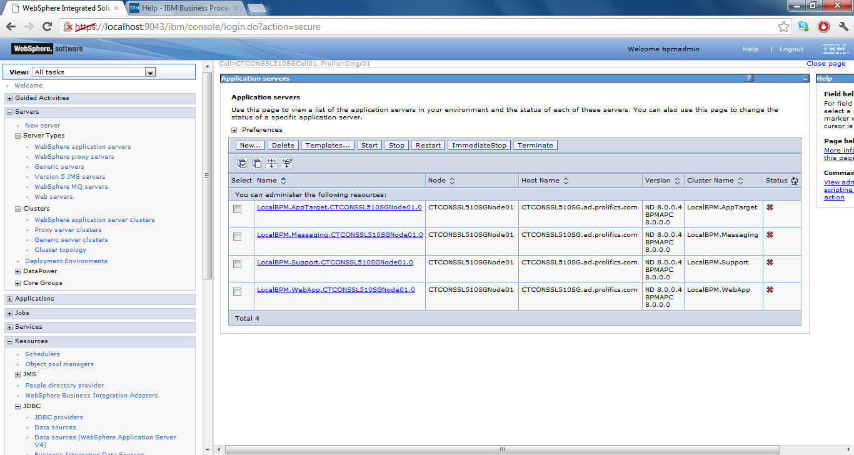

1. Select the checkbox next to LocalBPM.Messaging and click Start:

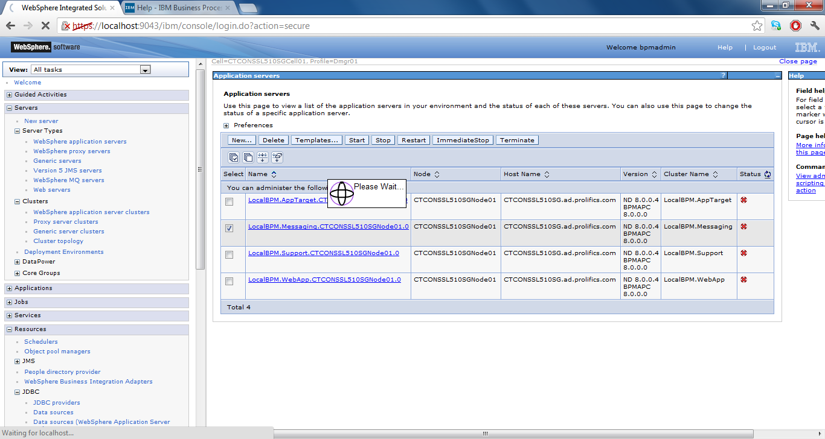

1. Check your application server logs for the server you are starting and ensure that there are no errors in the logs:

C:\IBM\WebSphere\AppServer\profiles\Custom01\LocalBPM.Messaging\SystemOut.log

1. Repeat steps 3-4 for until all application servers have start successfully following the start order I provided at the beginning of this section.